Blog Website

Wollo University

Kombolcha Institute of Technology

College of Informatics

Department of Software Engineering

We hereby submitted a project in partial fulfilment of bachelor Degree in Software Engineering

Title: Modern Social Blogging Platform Frontend Application

Submitted to the departments of Software Engineering

Name ID

Submission date: December 15, 2024

Discriminations

We hereby declare that our project titled "Modern Social Blogging Platform Frontend Application" is original and not submitted/Published by any individual/Organization.

Group Members

S.N. Name List ID Number Date: December 15, 2024 Sign

1.Ashenafi sileshi 0283/16

2.Kalkidan mengistu 1115/16

3.Israel Abera 4167/16

4.Briku Aytenew

5.Abraham Gebre/Medhin 0483/16

Advisor

Name: Mr. Nurye T (MSc)

Date of submission: December 1/4/2026 Sign: __________

**Approval of the Board of Examiners**

We, the undersigned, members of the Board of Examiners of the final open defense by List of students listed above, have read and evaluated their project entitled "Modern Social Blogging Platform Frontend Application" and examined the candidates. This is, therefore, to certify that the project has been accepted in partial fulfillment of the requirement of the degree of Bachelor in Software Engineering.

(Advisor) Signature Date

(Chairperson) Signature Date

(Examiner 1) Signature Date

(Examiner 2) Signature Date

(Examiner 3) Signature Date

**Summary**

Our project, the Modern Social Blogging Platform Frontend Application, is aimed at addressing the challenges and inefficiencies that are often associated with traditional blogging platforms, such as poor user engagement, limited social features, and outdated user interfaces. The system is being developed at Wollo University, specifically for the Software Engineering department. Through the use of modern web technologies and responsive design principles, we aim to improve user experience, increase engagement through social features, and provide an intuitive platform for content creation and consumption. We expect that our system will greatly benefit content creators and readers alike, and we believe that its potential impact will extend beyond our immediate community.

**Acknowledgement**

First of all, we would like to say thanks to almighty God for giving us strength to complete this project. We have taken effort in this project. However, it would not have been possible without the kind support and help of many individuals and staffs.

We would like to express our gratitude to Mr. Nurye T (MSc) our project Advisor, for his guidance, support, and invaluable feedback throughout the duration of this project. His vast knowledge and experience in the field of software engineering have been instrumental in ensuring the success of this project.

We would also like to extend our sincere thanks to the faculty members and staff of the Software Engineering Department at Wollo University for providing us with the necessary resources and facilities to undertake this project. We are grateful for their tireless efforts in mentoring and guiding us throughout the academic program.

Furthermore, we would like to thank the backend development team for their cooperation and providing us with the necessary API documentation to make this project a reality. We also appreciate their willingness to provide us with feedback and suggestions that have been instrumental in improving the quality and effectiveness of the frontend application.

Finally, we would like to express our gratitude to our families and friends for their support and encouragement throughout the course of this project. Their unwavering support and encouragement have been an inspiration to us and have helped us to overcome the challenges that we faced during the development of this project.

**Acronyms & Abbreviations**

**Acronyms Description**

BSP Blog Social Platform

UI User Interface

UX User Experience

FR Functional requirement

SRS System requirement specification

NFR Nonfunctional requirement

API Application Programming Interface

REST Representational State Transfer

JWT JSON Web Token

SPA Single Page Application

CRUD Create, Read, Update, Delete

RTK Redux Toolkit

CORS Cross-Origin Resource Sharing

CSS Cascading Style Sheets

JSX JavaScript XML

Vite Frontend Build Tool

**Definition**

**User Interface (UI):** The visual elements through which users interact with the blog platform.

**User Experience (UX):** The overall experience of users when interacting with the blog platform.

**Component:** Reusable UI building blocks in React that encapsulate functionality and styling.

**State Management:** The process of managing and sharing application state across components.

**Routing:** Navigation between different pages/views in a single-page application.

**API Integration:** Connecting the frontend application with backend services through API calls.

**Responsive Design:** Design approach that ensures optimal viewing across different devices.

**Authentication:** Process of verifying user identity through login/signup.

**Authorization:** Process of granting access rights to authenticated users.

**Real-time Updates:** Immediate updates to the UI without page refresh.

**Contents**

CHAPTER ONE

1.1 Introduction …………………………………………………………………………. 1

1.1.1 Background of the Project ……………………….…….……………………….. 1

1.1.2 Existing Systems …………………………….…….…………………. ………….2

1.1.3 Statement of Problem …………………………….….……………………………3

1.1.4 Proposed System 3 …………...………………….….……………………………3

1.2 Objective …………………………………………….….………………………….…5

1.2.1 General Objective .……………………………….….…………………………..…5

1.2.2 Specific Objective ………………………………………….….…………………..5

1.3 Scope and limitation ………………………………………….….…………………..6

1.3.1 Scope ………………………………………….….………………………….……6

1.3.2 Limitation of the project………………………………….….……………………..7

1.4 Methodology 7

1.4.1 Data collection and fact finding techniques 7

1.4.2 System analysis and design approach 7

1.4.3 Technology requirements 8

1.5 Feasibility Study 9

1.5.1 Operational feasibility 9

1.5.2 Economical feasibility 9

1.5.3 Technical feasibility 10

1.5.4 Legal feasibility 10

1.5.5 Political feasibility 10

1.6 Risk assessment strategy 11

1.7 Significance of the system 14

1.7.1 Beneficiary of the project 14

1.8 Schedule of the project 16

1.9 Project budget break-down and cost analysis, and Team composition 17

1.9.1 Project budget break-down and cost analysis 17

1.9.1 Team composition 17

CHAPTER TWO 18

System Requirement Specification 18

2.1 Background (Overview) 18

2.1.1 Scope 18

2.1.2 Purpose 18

2.1.3 Intended Audience and Suggested Readings 19

2.2 Overall Description of Software Requirements 20

2.2.1 Product Perspectives 20

2.2.2 User characteristics 21

2.3 General Constraints 24

2.3.1 Software constraints 24

2.3.2 Hardware Constraints 24

2.3.3 Assumptions and Dependencies 25

2.3.4 User Documentations 25

2.4 Specific Requirements 26

2.4.1 User requirements 26

2.4.2 Functional Requirements 27

2.4.3 Non-Functional Requirements 32

2.5 External Interface requirements 37

2.5.1 User Interfaces 37

2.5.2 Hardware Interface 39

2.5.3 Software Interface 39

2.5.4 Communication Interfaces 39

2.6 System requirements 39

2.7 Essential use case Diagrams 42

CHAPTER THREE 43

Requirement Analysis Modeling 43

3.1 Overview of Analysis Model 43

3.2 System use case Diagram 43

3.2.1 Scenario 43

3.2.2 Use case Model 46

3.2.3 Use case Description 47

3.3 Sequence Diagram 54

3.4 Activity Diagrams 60

CHAPTER FOUR 63

System Design 63

4.1 Overview 63

4.1.1 Design considerations and Purposes 64

4.1.2 Design goals 65

4.1.3 Design guidance and Issues 66

4.2 Proposed system architecture 66

4.2.1 System process 67

4.2.2 Subsystem decomposition 68

4.2.3 Hardware/Software mapping 69

4.2.4 Persistent data management 69

4.3 Design Control 69

4.4 Low-level design model 70

4.4.1 State chart diagram 70

4.4.2 Component diagram 72

4.4.3 Deployment diagram 73

4.5 Database Design 74

4.5.1 Data Dictionary 75

4.6 Boundary condition and Access control 77

4.6.1 Access controlling 77

4.7 Conclusion and Recommendation 78

4.7.1 Conclusions 78

4.7.2 Recommendation 78

4.8 Reference 80

List of Tables

Table 1: Risk assessment in risk information sheet 11

Table 2: The approach taken to solve the risk 13

Table 3: Schedule with grant chart 16

Table 4: Budgets 17

Table 5: Team Composition 17

Table 6: User Authentication 27

Table 7: Post Management 28

Table 8: Comment System 28

Table 9: Clap System 29

Table 10: Bookmark Management 29

Table 11: Follow System 30

Table 12: Notification System 30

Table 13: Topic Management 31

Table 14: User Profile Management 31

Table 15: Search Functionality 32

Table 16: Security 32

Table 17: Performance 33

Table 18: Reliability 33

Table 19: Portability 34

Table 20: Availability 34

Table 21: Usability 35

Table 22: Maintainability 35

Table 23: Scalability 36

Table 24: Interoperability 36

Table 25: User Component Data 75

Table 26: Post Component Data 75

Table 27: Comment Component Data 75

Table 28: Topic Component Data 76

Table 29: Notification Component Data 76

Table 30: Bookmark Component Data 76

List of Figures

Figure 1: Data flow diagram of Proposed Blog Platform 21

Figure 2: Login interface 37

Figure 3: User registration interface 38

Figure 4: Post creation interface 38

Figure 5: Essential use case of Proposed Blog Platform 42

Figure 6: Use case diagram of proposed Blog Platform 46

Figure 7: Sequence diagram of user authentication 54

Figure 8: Sequence diagram of post creation 55

Figure 9: Sequence diagram of comment management 56

Figure 10: Sequence diagram of clap system 57

Figure 11: Sequence diagram of notification system 58

Figure 12: Sequence diagram of follow system 59

Figure 13: Activity diagram of user authentication 60

Figure 14: Activity diagram of post creation 60

Figure 15: Activity diagram of comment management 61

Figure 16: Activity diagram of clap system 61

Figure 17: Activity diagram of bookmark management 62

Figure 18: Activity diagram of follow system 62

Figure 19: System architecture of proposed Blog Platform 67

Figure 20: System decomposition of proposed Blog Platform 68

Figure 21: State chart diagram of user authentication 70

Figure 22: State chart diagram of post management 71

Figure 23: Component diagram of proposed Blog Platform 72

Figure 24: Deployment diagram of proposed Blog Platform 73

Figure 25: Component structure of proposed Blog Platform 74

**CHAPTER ONE**

**1.1 Introduction**

Content creation and consumption have evolved significantly in the digital age, with social blogging platforms becoming essential tools for knowledge sharing, community building, and personal expression. Effective blogging platforms require seamless integration of content creation, social interaction, and user engagement features to deliver high-quality user experiences. Modern social blogging platforms play a crucial role in facilitating content discovery, enabling discussions, and fostering communities around shared interests.

The proposed Modern Social Blogging Platform Frontend Application includes user authentication, post creation and management, social interactions through comments and claps, personalized feeds, and notification systems. One of the critical components of the proposed system is the real-time update functionality. This functionality ensures that users receive immediate feedback on their interactions, providing content creators with the engagement metrics they need. The system also includes the ability to follow topics and users, bookmark posts for later reading, and maintain user profiles and reading history.

The blog platform software has the facility to give a unique user ID for every user and stores the details of every user and their posts automatically. It includes a search facility to discover content by keyword, topic, or user. Users can search for available topics and the details of any user using different search keys. This System can be accessed using credential accounts. It is accessible by all authorized users of the system.

The proposed Blog Platform is powerful, flexible, and easy to use and is designed and developed to deliver real conceivable benefits to content creators and readers. It is a software product suite designed to improve the quality and management of content creation in the areas of social interaction and community building. The System enables to develop the community and improve its effectiveness and quality of engagement.

**1.1.1 Background of the Project**

The Modern Social Blogging Platform Frontend Application is designed to provide a comprehensive solution for content creation, discovery, and community engagement in the digital space. Here is an overview of the project's vision, mission, and core values:

Vision: The platform's vision is to be a leading social blogging application in the digital space, recognized for its excellence in providing high-quality, user-friendly, and community-centered content experiences. The application aspires to be a center of excellence in content creation, social interaction, and user engagement, and to contribute to improving knowledge sharing and community building in the online space.

Mission: The platform's mission is to provide comprehensive and accessible blogging services that meet the needs of the community it serves. The application aims to provide content creation tools with a focus on user experience, engagement excellence, and community building, and to promote knowledge sharing through social features, content discovery, and user engagement. The platform also strives to collaborate with content creators and readers to enhance its capacity and capabilities in delivering exceptional blogging experiences.

Core Values:

User-Centered Design: The platform places users at the center of its design and development, respecting their preferences, privacy, and diversity. The application is committed to providing intuitive interfaces that are responsive to the creative, social, and informational needs of users.

Excellence: The platform strives for excellence in all aspects of its operations, including user interface design, user experience, performance, and feature implementation.

Integrity: The platform upholds the highest ethical standards in its interactions with users, content, and data privacy.

Community Engagement: The platform actively engages with the user community and partners with content creators, readers, and technology providers to improve content experiences and address the evolving needs of the digital community.

Overall, the platform is dedicated to providing high-quality, user-centered content experiences, promoting knowledge sharing and community building, and being a leading social blogging application in the digital space, guided by its vision, mission, and core values.

**1.1.2 Existing Systems**

Existing blogging platforms often suffer from fragmented user experiences, limited social features, and outdated interfaces. Many current systems require users to navigate between multiple applications for different functions, with user interfaces that don't follow modern design standards. Often features are incomplete or don't follow user experience best practices. User journeys are often lost in complex navigation structures requiring comprehensive user testing to ensure that no vital functionality is missing. Multiple implementations of the same features exist across different platforms and may lead to inconsistencies in user experience across various devices.

**1.1.3 Statement of Problem**

The current blogging platforms are not efficient in managing user engagement, content discovery, and providing real-time social interactions for better community building. This results in lower user retention, reduced engagement for content creators, and a negative overall impact on the quality of community interactions. Consequently, there is a need for a more effective and streamlined social blogging platform to improve digital content experiences.

Potential Problems:

Inefficient Content Discovery: Inefficient content discovery makes it difficult for users to find relevant information quickly, leading to reduced engagement and ultimately impacting community growth.

Limited Social Interaction Features: Limited social features lead to reduced user engagement, poor community interaction, and weak content promotion.

Lack of Immediate Updates: The content updates are very difficult to track and to find particular information. To find out about new posts or comments, the user has to refresh the page manually. This results in inconvenience and wastage of time.

Lack of Personalized Experience: The user experience generated by various interactions takes time and effort to be personalized for individual users.

Lack of Responsive Design: Various adjustments to interface elements for different devices are difficult to make as responsive design principles are not consistently applied.

Error Prone State Management: Manual state management is error prone and takes a lot of time, which may result in incorrect user interface states.

Preparation of Consistent User Interfaces: This becomes a difficult task as design components are difficult to reuse across different parts of the application.

Lack of Modern Features: The current systems lack adequate modern features, resulting in potential risks to user engagement and platform growth.

**1.1.4 Proposed System**

The proposed Modern Social Blogging Platform Frontend Application is designed to replace existing fragmented blogging experiences. The new system is to control the information of users, content creation, social interactions, and personalized content delivery. These services are to be provided in an efficient, cost-effective manner, with the goal of reducing the time and resources currently required for such tasks.

Advantages for Content Creators:

* Improved Content Creation: The system can provide creators with easy-to-use tools for creating and managing content, enabling them to focus on quality writing.
* Enhanced Engagement: The system can help streamline user interactions, increasing engagement through comments, claps, and follows.
* Better Analytics: Creators can track their content performance easily through the system, enabling quick access to engagement metrics and audience insights.
* Improved Community Building: The system can reduce the risk of community fragmentation by providing integrated social features.

Advantages for Readers:

* Enhanced Discovery: The system can help users discover relevant content, enabling them to find information that matches their interests.
* Improved Reading Experience: Users can customize their reading experience, enabling better content consumption.
* Streamlined Social Interactions: The system can automate many social interactions, such as following users, clapping for posts, and saving bookmarks, freeing up user time.
* Increased Satisfaction: The system can help users feel more connected to their interests and better able to engage with content.

Advantages for Platform Administrators:

* Better Resource Utilization: The system can help optimize frontend resource allocation, reducing load times and improving performance.
* Improved User Retention: The system can improve the quality of user experience, leading to better user retention and reduced churn rates.
* Enhanced Analytics: The system can help administrators understand user behavior and make data-driven decisions.

Recommendations for further research:

* Evaluation of Impact: Further research is needed to evaluate the impact of the blogging platform on user engagement, content quality, and community growth.
* User Acceptance: It is important to assess user acceptance of the system among different user groups, to identify any barriers to adoption and engagement.
* Technical Enhancements: The system can be further enhanced with the integration of advanced technologies, such as machine learning and artificial intelligence, to improve content recommendations and personalization.
* Accessibility: As the system will serve diverse users, further research should be conducted to ensure its accessibility and protect against exclusion of users with disabilities.

**1.2 Objective**

**1.2.1 General Objective**

The general objective of this proposed system is to develop a modern social blogging platform frontend application that provides exceptional user experiences and engagement features.

**1.2.2 Specific Objective**

* To collect accurate user requirements and understand content consumption patterns.
* Analyze the requirements and data collected to identify the key features and functionalities that the system should provide.
* Create a component model and state management schema to represent the entities and relationships involved in the blog platform's operations.
* To design a user-friendly system that allows users to access and interact with content quickly and easily.
* To design a system that meets all modern web standards, including accessibility and performance requirements.
* To develop the proposed system functionalities, such as user authentication, post creation, comment system, and social features.
* To evaluate the proposed system to ensure that the new system integrates seamlessly with existing user workflows, and monitor key performance indicators.

**1.3 Scope and limitation**

**1.3.1 Scope**

**Functional Scope:**

* The system will require users to login with their credentials to access personalized features. Users will have different levels of access depending on their authentication status.
* The system will allow authenticated users to create new posts by entering their content into rich text editors.
* The system will be available as a responsive web application accessible from multiple devices.
* The system will allow users to interact with content through comments, claps, and bookmarks.
* The system will be integrated with backend APIs to allow real-time updates and data synchronization.
* The system will provide personalized content feeds based on user interests and followed topics/users.
* The system will allow users to search for content by keyword, topic, or user.
* The system will provide notification systems for user interactions such as comments, claps, and follows.
* This feature includes functionalities like user authentication and authorization, role-based access control, as well as the system allowing all users to manage their profile.
* The system will calculate and display engagement metrics for content, such as clap counts, comment counts, and view counts.

**1.3.2 Limitation of the project**

* Limited Offline Functionality: The system requires internet connectivity for most operations and has limited offline capabilities.
* Browser Compatibility: The system is optimized for modern browsers and may have limited functionality in older browser versions.
* Mobile-Specific Features: Some features may be optimized differently for mobile versus desktop experiences.

**1.4 Methodology**

**1.4.1 Data collection and fact finding techniques**

**Interview:**

First, we identify the key stakeholders in the blogging platform, such as content creators, readers, and platform administrators. Then, we schedule interviews with each of these stakeholders to gather their input on what features and functionalities they would like to see in the system.

During the interviews, we ask open-ended questions to encourage the stakeholders to share their thoughts and ideas. For example, we asked a few questions like:

* What are some of the challenges you currently face in using blogging platforms?
* What features would you like to see in a new blogging platform?
* How do you currently discover and interact with content?

**Observation:**

In addition to conducting interviews, our team analyzed existing blogging platforms to gather data. We observe user interactions on popular platforms and take note of any inefficiencies or areas where a modern system could help streamline processes. For example, we observe users struggling with complex navigation and identify this as an area where a simplified interface could be implemented to improve user experience.

**1.4.2 System analysis and design approach**

**Development Approach:**

The development approach for the proposed blog platform frontend can follow a systematic approach, which includes several stages. These stages are:

**Project Initiation**: In this stage, we define the project scope, objectives, and goals and also we identify key stakeholders and establish project roles and responsibilities. Additionally, in this stage, we conduct initial feasibility studies and assess the resources required for the project.

**Requirements Gathering:** In this stage, we collect and analyze requirements for the blog platform frontend. This includes identifying the needs of different stakeholders, such as content creators, readers, and administrators. We create detailed documentation of the system requirements, including functional and non-functional requirements.

**System Design:** Once the requirements are gathered, we proceed with system design. This involves creating a blueprint of the blog platform frontend, including system architecture, component design, user interfaces, and other system components.

**Development:** In this stage, we start coding based on the system design. We follow coding standards and best practices to develop robust and secure software.

**Testing and Quality Assurance:** Once the development is complete, we conduct thorough testing of the system. This includes functional testing, performance testing, accessibility testing, and other types of testing to ensure the system meets the defined requirements and quality standards.

**Deployment:** After successful testing and quality assurance, the system is deployed to the production environment. This involves configuring the build process, optimizing assets, and making it available for end-users.

**Training and User Acceptance:** We will provide documentation on how to use the system effectively. We collect feedback from users and address any concerns or issues raised during the user acceptance testing.

Maintenance and Support: Once the system is live, the system can be updated and enhanced based on feedback from users and changing requirements.

**Project Closure:** Finally, the project is closed by conducting a thorough review of the project's success, including meeting project objectives, adherence to timelines and budgets, and stakeholder satisfaction.

**1.4.3 Technology requirements**

**Software requirement:**

**Modelling tools:**

* Figma: for UI/UX design and prototyping
* Draw.io: for creating diagrams

**Programming tools:**

* HTML5: to define the content of web pages
* CSS3: to specify the layout of web pages/formatting with modern features
* JavaScript (ES6+): program the behavior of web pages
* React.js: JavaScript library for building user interface
* Redux Toolkit: State management library
* React Router: Routing library for single-page applications
* Axios: HTTP client for API calls
* Vite: Frontend build tool and development server
* Tailwind CSS: Utility-first CSS framework
* VS Code: Text Editor with extensions
* Git: Version control system
* Web browsers (Chrome, Firefox, Safari)
* Microsoft Office 2021

**Hardware tools:**

* Laptop (PC) with minimum 8GB RAM
* External Storage for backup
* Network equipment for development environment
* Mobile devices for responsive testing

**1.5 Feasibility Study**

**1.5.1 Operational feasibility**

Nowadays, traditional blogging platforms do not satisfy modern user expectations and are not comfortable for content creators. But when the proposed system is implemented, users will get fast and engaging experiences and information as they want. Since the feature-rich frontend application will have a user-friendly interface and responsive design, it is technically feasible to implement this system.

**1.5.2 Economical feasibility**

The system reduces development costs when compared to traditional approaches because the system will use modern technology innovations and component-based architecture which will require efficient development processes.

**A. Tangible benefit:**

The system can provide several tangible economic benefits to platform operators and users. Here are some examples:

* Improved User Engagement: The system can provide users with quick access to content and social features, including personalized feeds, notifications, and interactions. This can lead to more effective content consumption and better user engagement, which can ultimately increase platform value.
* Reduced Development Costs: The system can help reduce development costs by using reusable components and modern development practices.
* Better Resource Utilization: The system can help optimize the use of resources such as bandwidth, server capacity, and development time.
* Cost Savings: By improving efficiency, reducing development time, and optimizing resource utilization, the system can help save money on a variety of costs, including development expenses, maintenance, and user acquisition.

**B. Intangible benefit:**

* Improved User Experience: Improved user experience can lead to increased user satisfaction and an overall improvement in the quality of the platform.
* Increased Community Engagement: The system can provide real-time information on user interactions, including engagement metrics, social connections, and content trends.
* Improved Data Visualization: The system can collect and display engagement data, allowing platform managers to identify trends, monitor performance, and make data-driven decisions.

**1.5.3 Technical feasibility**

The architecture of the system can be designed in such a way that it can handle complex user interfaces and state management. It is scalable, meaning it can adapt to changing demands and accommodate new features and functionalities.

Performance is also a critical consideration for blogging platforms, as they handle real-time user interactions, so the proposed system can be designed with robust performance measures, such as code splitting, lazy loading, and efficient state management, to protect against performance issues.

**1.5.4 Legal feasibility**

The proposed system will not conflict with any legal requirements and also the system works based on the rules and specifications of modern web standards in a good manner.

**1.5.5 Political feasibility**

In fact, nobody refuses modern systems because they address user experience problems and the technology community encourages new system products. This is the basis for the development of technology within our digital ecosystem. It is acceptable for all institutions and different organizations.

**1.6 Risk assessment strategy**

|  |  |  |  |  |  |  |  |
| --- | --- | --- | --- | --- | --- | --- | --- |
| Id | RISK | RISK DESCRIPTION | | IMPACT | TIME FRAME | CATEGORY | |
| Condition | Consequence | By source | By impact |
| R1 | Technical Complexity Risk | •Complex state management  •Integration with multiple APIs | Complex technical implementation can make the project fail | High | Near | Technical | High |
| R2 | UI/UX Design Risk | •Gathering ambiguous design requirements  •Changing design patterns | Ambiguous design requirements lead to confusion and rework, resulting in failed projects | High | Near | Design | High |
| R3 | Performance Risk | • Improper performance optimization  • Unexpected user load | The most common consequences of poor performance include user abandonment and reduced engagement | Moderate | Mid | Technical | Moderate |
| R4 | Browser Compatibility Risk | • Time is not estimated for cross-browser testing  • Improper polyfill implementation | Failing to plan for browser compatibility exposes the project to unexpected user experience issues | Moderate | Mid | Technical | Moderate |
| R5 | Scope Creep | •Changing requirements  • Adding new features | Scope creep is bad for a project as it leads to missed delivery dates, exceeding the budget, and poor quality of the final outcome | High | Far | Requirement | High |

**Table 2: The approach taken to solve the risk**

|  |  |  |  |  |  |  |
| --- | --- | --- | --- | --- | --- | --- |
| Id | Rank | RISK  owner | Approach | Scope and action | Control decision | Status |
| R1 | 1 | Gemechis Wondimu | Mitigation | Using established state management patterns and thorough API documentation | mitigate the risk: Minimize its probability and impact | Risk is controlled |
| R2 | 2 | Milkesa Fantahun | Mitigation | Gather proper design requirements and create comprehensive design system | Continue to tracking the design requirements | In progress |
| R3 | 3 | Amanuel Worku   |  | | --- | |  |  |  | | --- | |  | | Acceptance | Accept the risk and implement systematic performance monitoring and optimization | Close the risk and document it for closure | Risk is closed |
| R4 | 4 | Amanuel Tegegn | Acceptance | Accept the risk and add comprehensive cross-browser testing to the development process | Invoke contingency plan if compatibility issues occur | Risk is controlled |
| **R5** | 5 | Worku Eshete | Mitigation | Clearly define and document project requirements early in the project | Re-plan scope changes through formal change control | Risk is planned |

**1.7 Significance of the system**

The proposed Modern Social Blogging Platform Frontend Application is significant for several reasons, including:

**Improved User Experience:** The System will provide users with intuitive and responsive interfaces, enabling them to create and consume content more effectively, leading to improved user satisfaction.

**Efficient Social Interaction:** The System will streamline social features, enabling users to engage with content and community more efficiently, which will enhance community building.

**Enhanced Accessibility:** The proposed System will incorporate robust accessibility features to ensure that all users can access content regardless of abilities, promoting inclusivity and equal access.

**Seamless Content Discovery:** The proposed System will enable seamless content discovery through personalized feeds and search functionality, promoting content visibility and user engagement, resulting in improved content consumption and outcomes.

**1.7.1 Beneficiary of the project**

For **Platform Operators:**

**Streamlined Operations:** The system can automate and streamline various user interface and experience tasks, such as content display, user interactions, and notifications. This can improve the overall efficiency of the platform, reduce development errors, and save time and effort for developers, ultimately leading to enhanced user satisfaction.

**Enhanced User Engagement**: The system can provide real-time access to engagement metrics, including user interactions, content performance, and community growth. This allows platform operators to make informed decisions and provide personalized experiences to users. It can also help in tracking user behavior and monitoring outcomes, which can result in improved user retention and better platform management.

**Enhanced Communication and Collaboration**: The system can facilitate seamless communication and collaboration among various user groups and stakeholders on the platform, including content creators, readers, and administrators. This can improve community coordination, reduce communication gaps, and enhance overall community building, resulting in better user experiences and outcomes.

**Compliance and Security:** The system can help in maintaining user privacy and data security, mitigating risks of data breaches and ensuring compliance with legal requirements.

**For System Users:**

The beneficiary for system users can include various stakeholders involved in the creation and consumption of content. Some potential beneficiaries of the system for system users include:

**Content Creators:** Content creators can benefit from the system as it can provide them with tools to create and manage content effectively, such as rich text editing, content scheduling, engagement tracking, and overall management of their content portfolio.

**Readers:** Readers can benefit from the system as it can streamline their content discovery, provide access to personalized content feeds, assist in content interaction through comments and claps, and facilitate communication and coordination among different community members within the platform.

**Community Members:** Community members can benefit from the system as it can improve their experience by providing them with convenient options for content interaction, access to community features, and communication with other users. It can also help in reducing friction and improving community safety through proper moderation tools.

**For Developers (us):**

As developers, implementing the system can bring several benefits. Some of the key benefits of the system for developers include:

**Streamlined Development Workflow:** A well-designed system can help optimize the development workflow. As developers, we can create software that automates various development tasks. This can result in improved efficiency and productivity for development teams, reducing manual errors and improving overall code quality.

**Customization and Scalability:** Developing the system allows us to create a solution that can be tailored to the specific needs of the blogging platform. We can design components that can be easily customized and scaled up or down based on the requirements of the platform. This flexibility allows for better adaptability to changing platform requirements and growth in the future.

**Enhanced Code Management:** As developers, we can create robust code management systems that ensure code quality, maintainability, and compliance with relevant coding standards.

**Integration and Interoperability:** As developers, we can create a blogging platform frontend that integrates and interoperates with backend systems, allowing for seamless data exchange and communication between different system components. This can help streamline operations and reduce development complexity, leading to increased efficiency.

**1.8 Schedule of the project**

**Table 3: Schedule with grant chart**

|  |  |  |  |  |  |
| --- | --- | --- | --- | --- | --- |
| **Activities** | **Sept 1–17, 2024** | **Sept 18–27, 2024** | **Sept 28–Oct 15, 2024** | **Oct 16–30, 2024** | **Nov 5–Dec 18,2024** |
| **Gathering Requirements** | **■** |  |  |  |  |
| **UI/UX Design** | **■** | **■** |  |  |  |
| **System Analysis** |  | **■** | **■** |  |  |
| **System Design** |  |  | **■** | **■** |  |
| **Implementation** |  |  |  | **■** | **■** |
| **Testing & Deployment** |  |  |  |  | **■** |

1.9 Project budget break-down and cost analysis, and Team composition

1.9.1 Project budget break-down and cost analysis

**Table 4: Budgets**

|  |  |  |  |
| --- | --- | --- | --- |
| Item | Quantity | Unit Price | Total Price |
| PC | 2 | 35,000 | 70,000 |
| Software Licenses | 5 | 2,000 | 10,000 |
| Internet Subscription | 6 months | 1,000 | 6,000 |
| Other Materials | — | —- | 5,000 |
| Printing Documents | — | — | 3,000 |
| **Total Cost** |  |  | **94,000** |

**1.9.1 Team composition**

**Table 5: Team Composition**

|  |  |  |
| --- | --- | --- |
| No | Name | Role |
| **1** | **Gemechis Wondimu and Amanuel Tegegne** | **Gathering Requirements & UI/UX Desig** |
| **2** | **Amanuel Worku and Worku Eshete** | **System Analysis and Architecture** |
| **3** | **Milkesa Fantahun and Gemechis Wondimu** | **System Design and Component Architecture** |
| **4** | **Amanuel Worku and Milkesa Fantahun** | **Implementation of the Syste** |

**CHAPTER TWO**

System Requirement Specification

**2.1 Background (Overview)**

The proposed system is a frontend software solution designed to provide an intuitive and engaging user interface for a modern social blogging platform. It aims to enhance the overall user experience, engagement, and quality of content interaction while reducing interface complexity and improving communication among different user groups and system components.

**2.1.1 Scope**

The scope of the SRS for a proposed blog platform frontend is to define the requirements for the development of a comprehensive, responsive web application that will manage all aspects of user interaction with the blogging platform. The SRS defines the functional and non-functional requirements for the system. In terms of functional requirements, the SRS defines the modules that will be included in the proposed system and their respective functionalities, such as user authentication, post management, comment system, clap system, and notification system. It also defines the workflows between these modules.

In terms of non-functional requirements, the SRS defines the performance requirements, such as response times, throughput, and scalability. It also defines the security requirements, such as access control, data encryption, and audit trails. Additionally, the SRS defines the usability and user experience requirements, such as ease of use, accessibility, and user training.

The SRS of this proposed system also defines the constraints and assumptions that will guide the development of the system, such as the target hardware and software platform, the development methodology, and the development timeline.

**2.1.2 Purpose**

The Purpose of the Modern Social Blogging Platform Frontend in the context of Software Requirements Specification (SRS) is to clearly define the objectives, functionalities, and specifications of the proposed frontend software.

The key purposes of the Blog Platform Frontend, as described in the SRS, include:

The Blog Platform Frontend have features to manage user interactions, including authentication, content creation, social engagement, notifications, and facilitating communication between users and content.

The Blog Platform Frontend can be designed to handle a large volume of user interactions and content, with good performance and scalability to accommodate future growth and expansion of the platform.

The system can be scalable and flexible, capable of handling a large volume of data and accommodating the evolving needs of the platform as it grows and changes.

Overall, the purpose of this proposed Blog Platform Frontend, as outlined in the SRS, is to provide a comprehensive, efficient, and user-friendly software solution that meets the needs of platform users, content creators, and administrators, and ensures smooth and effective platform operations.

2.1.3 Intended Audience and Suggested Readings

The document for a proposed blog platform frontend project have different intended audiences or types of readers, each with their specific needs and requirements. Some of the potential types of readers for such a document include:

**Developers**: This audience consists of frontend developers who will be responsible for designing, coding, and implementing the system. They will require technical details such as system architecture, programming languages, libraries, and frameworks used, component design, and other technical specifications. The document also provide information on coding standards, best practices, and guidelines to follow during development.

**Users:** This audience comprises platform users who will be using the blogging system on a day-to-day basis. Include content creators, readers, and community members. They will require information on how to use the system effectively to perform tasks such as user registration, post creation, commenting, and generating engagement. The document provide user guides, and instructions on how to navigate the system's user interface, input data, and retrieve information.

T**esters:** This audience consists of quality assurance (QA) testers who will be responsible for testing the system to identify and report any defects or issues. They will require information on test plans, test cases, and test scenarios to validate the system's functionality, performance, security, and usability. The document also provide information on how to reproduce issues, log defects, and conduct regression testing.

**Document Writers:** This audience comprises technical writers or documentation specialists who will be responsible for creating documentation related to the system. They will require information on the system's features, functionality, and technical specifications to create comprehensive documentation. The document provide details on system configuration, installation instructions, troubleshooting guides, and other documentation requirements.

**Stakeholders:** This audience includes project managers, executives, and other stakeholders who are involved in the system. They will require high-level information such as project goals, objectives, scope, timelines, and budget. The document provide executive summaries, project overview, and other relevant information for decision-making and project management purposes.

**2.2 Overall Description of Software Requirements**

This Software Requirements Specification (SRS) is the requirements work product that formally specifies Modern Social Blogging Platform Frontend. It includes the results of both business analysis and systems analysis efforts. The detail structure of this document is organized as follows:

**Section 1** of this document describe the introduction, objective, scope and limitation, methodology, feasibility study, risk assessment strategy, significance, schedule, budget and the team composition.

**Section 2** of this document describe the SRS of the proposed Blog Platform Frontend. These include overview, scope, purpose, Document convention, General constraint, specific requirement, external requirement, system requirement, essential use case and any assumptions for this system.

**Section 3** of this document describe the requirement analysis modeling such as, system use case (use case model, scenario, and use case description), sequence diagram and activity diagram of the proposed system.

**Section 4** of this document deal with the system design of proposed system. These include overview, system architecture, design control, low level design model and data base design.

**2.2.1 Product Perspectives**

From a product perspective, the blog platform frontend is a comprehensive software solution that is designed to streamline and automate various user interaction, content consumption, and social engagement processes within a blogging platform. It is intended to improve efficiency, enhance user experience, and optimize engagement.

The Blog Platform Frontend serves as an integrated solution that consolidates multiple functions and features within a blogging platform into a single software platform. It typically includes modules for user authentication, post management, comment system, clap system, bookmark system, follow system, notification system, topic management, and user profile management. The integrated nature of the Blog Platform Frontend allows for seamless data flow and communication between different features, reducing duplication of effort and improving overall coordination and collaboration.

The Blog Platform Frontend can be customizable to meet the specific needs of a blogging platform. It allow for configuration of themes, layouts, components, and other parameters to align with the platform's unique branding and requirements.

The system have a user-friendly interface that is easy to navigate and use for all types of users, including users with varying levels of technical expertise. And prioritize data security and compliance with relevant regulations. It have robust security features, including access controls, encryption to protect user information from unauthorized access or breaches.

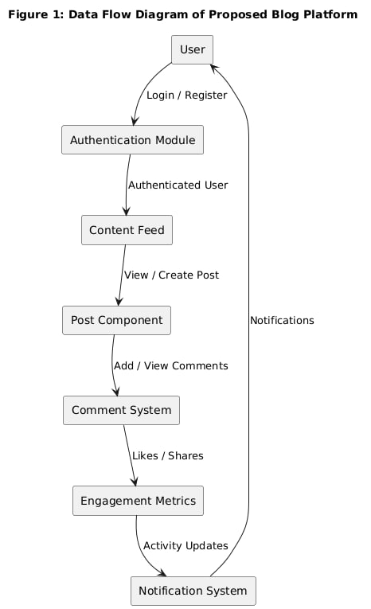

Figure 1: Data flow diagram of Proposed Blog Platform

**2.2.2 User characteristics**

**Guest User Module:**

Guest users have limited access to the system which means they can only view public content. They are the basic users who can browse the platform without authentication.

* A Guest User can view public posts and comments without logging in.
* Can view user profiles (public information only).
* Can browse topics and categories.
* Can search for content.
* Cannot create posts, comments, or engage with content.

**Registered User Module:**

Registered users have full access to content creation and social features. They are authenticated users who can participate in all platform activities.

* A Registered User can login into the system and perform any of the available operations.
* Can create, edit, and delete their own posts.
* Can comment on posts.
* Can clap for posts and comments.
* Can bookmark posts.
* Can follow other users and topics.
* Can manage their profile and settings.
* Can receive and manage notifications.

**Content Creator Module:**

This is the user why a system is introduced. A content creator can create and manage posts, track engagement, and build their audience. Thus, the content creator can clearly know what content resonates with their audience and how they should optimize their content strategy. Content creators can perform the following function:

* Can view their post analytics and engagement metrics.
* Can create and manage drafts.
* Can publish and unpublish posts.
* Can view their follower statistics.
* Can manage their content portfolio.

**Administrator Module:**

Administrators have the full access to the system which means they can manage any activity with regard to the system. They are the highest privileged users who have full access to the system.

* An Administrator can login into the system and perform any of the available operations.
* Can manage user accounts (enable/disable users).
* Can manage content (moderate posts and comments).
* Can manage topics and categories.
* Can view system analytics and reports.
* Can access all the details of the users of the system.

**Moderator Module:**

Moderators help maintain community standards and ensure positive user experiences. They can perform the following function:

* Can review and moderate posts and comments.
* Can manage reported content.
* Can communicate with users about community guidelines.
* Can temporarily suspend user privileges for violations.

**2.3 General Constraints**

**2.3.1 Software constraints**

Here are some potential software constraints of the system:

**Scalability:** The systems need to handle a large volume of user interactions, including posts, comments, claps, and notifications. As the size of a platform grows, the system must be able to scale accordingly to accommodate the increased data and user load.

**Integration with backend systems:** The platform has existing backend systems and APIs in place for various functions such as authentication, data storage, and real-time updates. Integrating a frontend system with these existing systems may pose challenges in terms of interoperability, data exchange, and system integration.

**Customization and flexibility:** The system needs to be highly customizable and flexible to adapt to the unique needs of different user segments.

Security and privacy: The systems handle sensitive user data, including personal information and engagement data. Therefore, ensuring the security and privacy of user data is crucial.

User interface and user experience: The usability of the system is critical for efficient and effective usage by diverse users.

Technical support and maintenance: The systems require ongoing technical support and maintenance to ensure smooth operations and timely issue resolution.

Cost: Implementing the system can involve significant costs, including development tools, hosting infrastructure, implementation, and ongoing maintenance, so there is cost constraints.

2.3.2 Hardware Constraints

Here are some common hardware constraints that can be encountered within the system:

Device Compatibility: The system must be compatible with various devices that users may use to access the platform, including desktop computers, laptops, tablets, and smartphones. The system should be responsive and adapt to different screen sizes and resolutions.

Browser Compatibility: The system must be compatible with different web browsers that users may use, such as Chrome, Firefox, Safari, and Edge. The system should work consistently across different browsers and versions.

Network Infrastructure: The system require a robust networking infrastructure to facilitate communication between the frontend and backend systems, as well as real-time updates and notifications.

Security Measures: The platform deals with sensitive user information, and the system must have robust security measures in place to protect user privacy and comply with data protection regulations. This include encryption and other security measures that can impose additional hardware requirements.

Scalability: Platforms are dynamic environments that can experience changes in user volume and system requirements over time.

**2.3.3 Assumptions and Dependencies**

* People who are not familiar with computers and smart phones may find some features challenging to use.
* The system can be designed to comply with all relevant laws, regulations, and industry standards related to web accessibility, data privacy, and security.
* The system will be scalable and extensible to accommodate future enhancements and modifications as needed.
* The system will be operating in modern web environments and easy to use.
* It is assumed that the Platform will have enough technical support to maintain the system.
* The user name and password must be created by users during registration.
* Roles and permissions are predefined.

Users have basic understanding of web browsers, navigation, and internet usage.

**2.3.4 User Documentations**

This system is designed to help users create, discover, and engage with content in a modern blogging platform. This documentation will provided with a comprehensive guide on how to use the system effectively. Some possible functions that can be covered in the user documentation for the proposed system are:

Logging In: To access the System, the user should enter username and password on the login page. Once logged in, they will be taken to the system's dashboard, which provides an overview of key information and options.

User Registration: To register as a new user, click on "Sign Up" tab, fill in the required user information, such as name, email, username, and password. After fill the form Click on "Create Account" to add user to the system.

Post Creation: To create a new post, click on "Create Post" button. Then fill the relevant information including title, content, and topics. After fill the information, click on "Publish" or "Save as Draft" button.

Comment System: To add comments to posts, go to the post detail page and scroll to the comments section. Type your comment in the text area and click "Post Comment" to add your comment to the discussion.

Clap System: To show appreciation for a post or comment, click on the "Clap" button associated with the content. You can click multiple times to add more claps.

Bookmark Management: To save posts for later reading, click on the "Bookmark" icon on any post. To view your bookmarks, go to your profile and click on "Bookmarks" tab.

Follow System: To follow other users or topics, click on the "Follow" button on user profiles or topic pages. You can manage your follows from your profile settings.

Notification System: The System have features for managing notifications for various interactions. You can view notifications by clicking on the bell icon, mark notifications as read, and configure notification preferences in settings.

Logging Out: It's important to log out of the system when you're done using it to ensure the security of your account and system access. To log out, simply click on your profile picture and select "Log Out" from the dropdown menu.

Finally, we hope this information helps users effectively use the system to manage their blogging activities and engage with the community.

**2.4 Specific Requirements**

**2.4.1 User requirements**

User requirements in proposed blog platform frontend typically refer to the specific needs and expectations of the users, who are the individuals or entities that will interact with and benefit from the system. Here are user requirements of Blog Platform Frontend:

* The system allow users to register new accounts, manage their personal and profile information, and maintain an up-to-date and organized record of user data and enable users to create, edit, and manage posts with rich text formatting and media support.
* The system have features for tracking user engagement such as comments, claps, and follows and allow for following users and topics, tracking engagement metrics, and managing notification preferences.
* The system support integration with other systems and technologies such as authentication systems, analytics tools, and social media platforms.
* The system have an intuitive and user-friendly interface that is easy to navigate for all types of users, and be accessible via mobile devices, allowing users to access and manage their content.
* The system can be scalable and flexible, capable of handling a large volume of data and accommodating the evolving needs of the platform as it grows and changes.

**2.4.2 Functional Requirements**

The functional requirement of the proposed Blog Platform Frontend is shown below within the following table:-

Table 6: User Authentication

|  |  |
| --- | --- |
| FR-1 | FR-1 |
| Requirement Name | User Authentication |
| Requirement Statement | The system must allow users to authenticate securely to access the system. |
| Detailed Description | The system shall provide functionality for users to register new accounts by capturing personal information such as full name, email address, username, and password. The system shall implement a secure login mechanism using JSON Web Token (JWT)–based authentication and authorization to ensure only authenticated users can access protected resources. Passwords must be securely stored using hashing techniques |
| Category | Functional Requirement – Authentication |
| Source | End User |
| Priority | High |
| Preconditions | The user must have a registered account in the system |
| Postconditions | Upon successful authentication, the user is granted access to authorized system features based on their role. |
| Inputs | Username or Email, Password |
| Outputs | Authentication token (JWT), login success or error message |
| Security Constraints | Passwords must be encrypted using secure hashing (e.g., bcrypt). JWT tokens must expire after a defined session period |

Table 7: Post Management

|  |  |
| --- | --- |
| Requirement ID | FR-2 |
| Requirement | The system must allow users to create, read, update, and delete posts. |
| Description | Implement comprehensive post management system including rich text editing, media upload, draft saving, publishing, and post categorization by topics. |
| Category | Post Management |
| Source | Content Creator |
| Priority | High |
| Related Requirements | The system allow users to view post analytics and engagement metrics. |

Table 8: Comment System

|  |  |
| --- | --- |
| Requirement ID | FR-3 |
| Requirement | The system shall allow users to add comments to posts and manage their comments. |
| Description | The system shall have the capability to add comments to posts, reply to comments, edit comments, and delete comments. Users should be able to view comment threads and engage in discussions. |
| Description | The system shall have the capability to add comments to posts, reply to comments, edit comments, and delete comments. Users should be able to view comment threads and engage in discussions. |
| Category | Comment System |

Table 9: Clap System

|  |  |
| --- | --- |
| Requirement ID | FR-4 |
| Requirement | Users can express appreciation for posts and comments through claps |
| Description | Allows users to clap for posts and comments to show appreciation. The system provides visual feedback, tracks clap counts, and lets users see who clapped for their content. |
| Category | Clap System |
| Source | Registered User |
| Priority | High |
| Related Requirements | FR-1 (User Authentication), FR-2 (Post Management), FR-3 (Comment Management) |

Table 10: Bookmark Management

Requirement ID FR-5

Requirement The system

|  |  |
| --- | --- |
| Requirement ID | FR-5 |
| Requirement | Users can express appreciation for posts and comments through claps. |
| Description | Allow users to clap for posts and comments to show appreciation. Provide |
| Source | Registered User |
| Priority | High |
| Related Requirements |  |

Table 11: Follow System

|  |  |
| --- | --- |
| Requirement ID | FR-6 |
| Requirement | he system must allow users to follow other users and topics |
| Description | Implement a follow system that allows users to follow other users to see their content in personalized feeds and follow topics to discover relevant content. Provide functionality to manage follows and view follow statistics. |
| Source | Registered User |
| Priority | High |
| Related Requirements | FR-1 (User Authentication), FR-2 (Post Management), FR-3 (Topic Management) |
| category | Follow syatem |

___

Table 12: Notification System

|  |  |
| --- | --- |
| Requirement ID | FR-7 |
| Requirement | The system shall notify users about relevant activities |
| Description | The system have real-time notification system that alerts users about comments on their posts, claps, new followers, and other relevant activities. Users should be able to manage notification preferences and mark notifications as read. |
| Category | Notification System |
| Source | Registered User |

Table 13: Topic Management

|  |  |
| --- | --- |
| Requirement ID | FR-8 |
| Requirement | The system shall allow categorization of posts by topics. |
| Description | The System maintain a comprehensive and up-to-date list of topics and categories for content organization. Users should be able to browse topics, follow topics, and filter content by topics. |
| Category | Topic Management |
| Source | Administrator and User |

|  |  |
| --- | --- |
| Related Requirements | The system allow users to discover content by topics. |

Table 14: User Profile Management

|  |  |
| --- | --- |
| Requirement ID | FR-9 |
| Requirement | The system shall allow all users to manage their profile. |
| Description | Allow users to view and update their personal information, such as display name, bio, avatar, and social links. Users should be able to view their activity history, statistics, and manage account settings. |
| Category | User Profile Management |
| Source | All Registered Users |
| Priority | Medium |
| Related Requirements | The system provide user profile pages for public viewing. |

.

Table 15: Search Functionality

|  |  |
| --- | --- |
| Requirement ID | FR-10 |
| Requirement | The system shall provide comprehensive search capabilities. |
| Description | The System maintain search functionality that allows users to search for posts, users, and topics by keywords. Search should include filters, sorting options, and relevant results ranking |
| Category | Search Functionality |
| Source | All Users |
| Priority | Medium |
| Related Requirements | The system provide advanced search filters and saved searches. |

2.4.3 Non-Functional Requirements

Table 16: Security

|  |  |
| --- | --- |
| Requirement ID | NFR01 |
| Requirement | The system use encryption for all user data, enforce strong authentication and authorization mechanisms |
| Description | Ability to protect user data and comply with relevant data protection laws, ensuring confidentiality, integrity, and availability of user information. |
| category | Security  Source System |
| Related Requirements | he system provide advanced security filters anddo not hacked |

Table 17: Performance

|  |  |
| --- | --- |
| Requirement ID | NFRR02 |
| Requirement | The System perform well in different scenarios |
| Description | The system must respond quickly and efficiently to user requests and handle a large number of concurrent users without experiencing significant delays or slowdowns. Page load times should be under 3 seconds for optimal user experience. |
| category | Performance |
| Source | system |

Table 18: Reliability

|  |  |
| --- | --- |
| Requirement ID | NFR03 |
| Requirement | The system must be highly reliable and available, with minimal downtime or system failures |
| Description | The system must be highly reliable and available, with minimal downtime or system failures, to ensure uninterrupted access to platform features and user data. System uptime should be 99.9% or higher. |
| category | Reliability |
| Source | system |

___

Table 19: Portability

|  |  |
| --- | --- |
| Requirement ID | NFR04 |
| Requirement | The system must be able to run on multiple platforms and browsers. |
| Description | The system can run on multiple platforms, such as Windows, macOS, Linux, iOS, and Android, and is compatible with popular web browsers like Chrome, Firefox, Safari, and Edge. This ensures easy access and a consistent user experience across devices |
| Category | Portability |
| category | portability |
| source | system |

Table 20: Availability

|  |  |
| --- | --- |
| Requirement ID | NFR05 |
| Requirement | The proposed system shall be accessible 24×7 without failure. |
| Description | The system is designed and implemented to ensure high availability, allowing it to remain accessible and operational with minimal downtime. Redundancy and failover mechanisms are used to prevent service interruptions. |
| Category | Availability |
| Source | System |
| Related Requirements | The system is available to users with an internet connection. |

Table 21: Usability

|  |  |
| --- | --- |
| Requirement ID | NFR06 |
| Requirement | The system must have a good-looking, user-friendly interface that is easy for users to use. |
| Description | The system provides a user-friendly interface with intuitive navigation, consistent design patterns, and comprehensive user documentation and help features. The interface follows modern design principles and accessibility standards. |
| Category | usability |
| source | system |
| Related Requirements | The system must have a good arrangement of objects and a clear visual hierarchy. |

Table 22: Maintainability

|  |  |
| --- | --- |
| Requirement ID | NFR07 |
| Requirement | The system must be easy to modify and maintain. |
| Description | the system is designed using a modular and scalable architecture, with clear documentation and coding standards. It follows industry-standard coding practices and is well-documented to facilitate future updates and enhancements. |
| Category | Maintainability |
| source | system |

Table 23: Scalability

|  |  |
| --- | --- |
| Requirement ID | NFR08 |
| Requirement | The system must be able to handle increasing volumes of user data and interactions over time, without degradation in performance or loss of functionality. |
| Description | The system must support the addition of user accounts and content without any impact on system performance or functionality. The system should scale horizontally to handle growth |
| Category | Scalability |
| Source | System |

___

Table 24: Interoperability

|  |  |
| --- | --- |
| Requirement ID | NFR09 |
| Requirement | The system must be able to integrate with other systems and APIs, |
| Description | The system must be able to integrate with other systems and APIs, such as authentication services, analytics platforms, and social media sharing to enable seamless data exchange and workflow coordination. |
| category | Interoperability |
| Source | System |

__

**2.5 External Interface requirements**

**2.5.1 User Interfaces**

The proposed system have intuitive and user-friendly interfaces to allow different types of users, such as content creators, readers, and administrators, to interact with the system. The user interfaces can be designed to be accessible and usable by individuals with disabilities, complying with relevant accessibility standards.

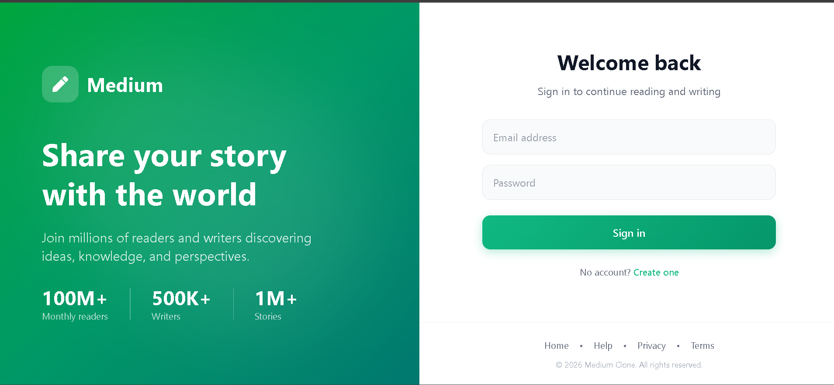

Figure 2: Login interface

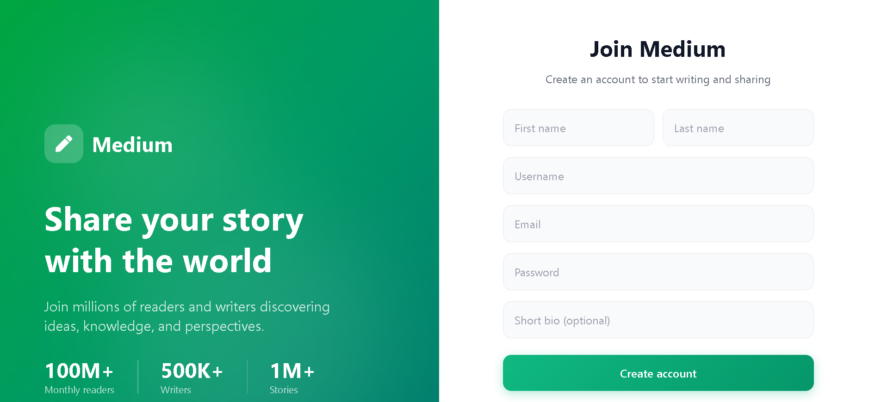Figure 3: User registration interface

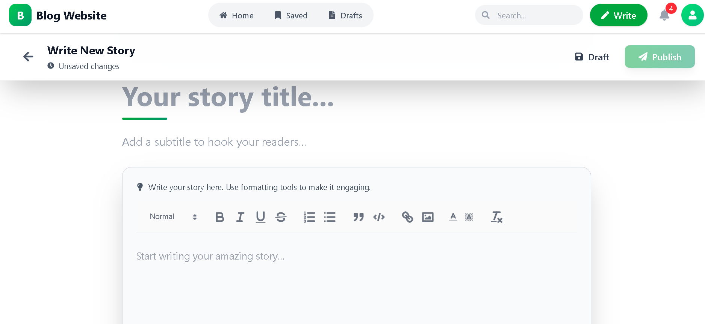

Figure 4: Post creation interface

**2.5.2 Hardware Interface**

* Laptop/Desktop PC
* Core i5 processor or equivalent
* 8GB RAM minimum
* 256GB SSD storage
* Mobile Devices
* iOS and Android smartphones and tablets
* Touch screen compatibility
* Network Requirements
* Stable internet connection
* Minimum 5 Mbps download speed

**2.5.3 Software Interface**

* Web Browsers
* Chrome 80+
* Firefox 75+
* Safari 13+
* Edge 80+
* Operating Systems
* Windows 10+
* macOS 10.14+
* Linux distributions
* iOS 13+
* Android 9+
* Development Tools
* Node.js 16+
* npm/yarn package managers
* Git for version control

**2.5.4 Communication Interfaces**

The system require communication interfaces with backend APIs to exchange data and perform operations. These interfaces should be able to transmit data accurately and securely, following RESTful principles for data exchange and interoperability. The system need to interface with authentication APIs, content APIs, notification APIs, and analytics APIs.

The communications functions required by this product are HTTP/HTTPS connections with the backend server so that the frontend can communicate with backend services via:

* RESTful API endpoints
* WebSocket connections for real-time updates

HTTP/2 protocol for improved performance

**2.6 System requirements**

The following describes the main functional requirement of Proposed Blog Platform Frontend:-

**Requirement ID: FR-1**

**Requirement Name:** User Authentication

* User-friendly authentication process for new users and returning users.
* Ability to capture and store relevant information such as name, email, username, and password during registration.
* Verification and validation of registration information to ensure accuracy and uniqueness.
* Secure storage of authentication data and implementation of JWT-based authentication.
* Password recovery functionality through email verification and secure reset process.

**Requirement ID: FR-2**

**Requirement Name:** Post Management

* Comprehensive post creation interface with rich text editing capabilities.
* Support for media uploads including images, videos, and documents.
* Draft management system for saving and editing unpublished posts.
* Post categorization and tagging system for content organization.
* Post analytics and engagement metrics display for content creators.

**Requirement ID: FR-3**

**Requirement Name:** Comment System

* Nested comment system supporting replies and threads.
* Real-time comment updates without page refresh.
* Comment moderation tools for content creators and moderators.
* Rich text formatting support in comments.
* Notification system for comment interactions.

**Requirement ID: FR-4**

**Requirement Name:** Clap System

* Visual clap button with animation feedback.
* Multiple clap capability (users can clap multiple times).
* Clap counter display with real-time updates.
* Clap history and analytics for content creators.
* Integration with notification system for clap alerts.

**Requirement ID: FR-5**

**Requirement Name:** Bookmark Management

* Bookmark button with visual state indication.
* Bookmark organization system with folders or tags.
* Quick access to bookmarked content from user profile.
* Reading progress tracking for bookmarked content.
* Export functionality for bookmark lists.

**Requirement ID: FR-6**

**Requirement Name:** Follow System

* Follow/unfollow buttons with visual feedback.
* Follower/following counts with real-time updates.
* Personalized feed based on followed users and topics.
* Follow suggestions and recommendations.
* Follow management interface in user profile.

**Requirement ID: FR-7**

**Requirement Name**: Notification System

* Real-time notification delivery without page refresh.
* Notification categorization (comments, claps, follows, etc.).
* Notification preferences and settings management.
* Batch operations for marking notifications as read.
* Notification history and archive.

**Requirement ID: FR-8**

**Requirement Name:** Topic Management

* Topic browsing interface with categorization.
* Topic following/unfollowing functionality.
* Content discovery by topics.
* Topic trending and popularity indicators.
* Topic creation and management (admin only).

**Requirement ID: FR-9**

**Requirement Name:** User Profile Management

* Comprehensive user profile pages with public and private sections.
* Profile customization (avatar, cover image, bio, social links).
* Activity feed showing user's posts, comments, and engagements.
* Statistics display (follower counts, post counts, engagement metrics).
* Privacy settings and account management.

**Requirement ID: FR-10**

**Requirement Name:** Search Functionality

* Full-text search across posts, users, and topics.
* Advanced search filters (date, popularity, content type).
* Search suggestions and autocomplete.
* Saved searches and search history.
* Search results pagination and sorting.

**2.7 Essential use case Diagrams**

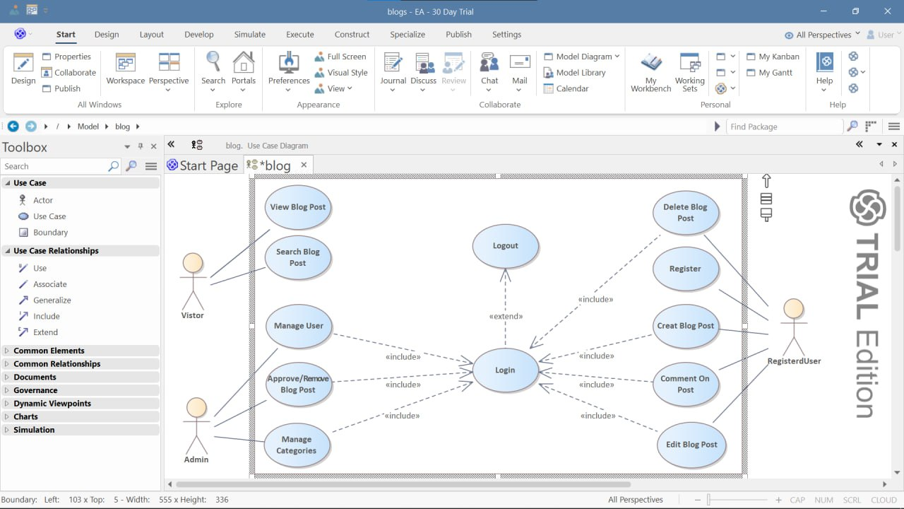

Figure 5: Essential use case of Proposed Blog Platform

**CHAPTER THREE**

**Requirement Analysis Modeling**

**3.1 Overview of Analysis Model**

The analysis model of this proposed system typically includes several key components that are designed to capture and describe the various aspects of blog platform operations and user interactions, such as use case diagram, activity diagram, and sequence diagram.

Overall, these three types of diagrams work together to provide a comprehensive overview of the interactions and functionalities of a blog platform frontend. Use case diagrams capture the high-level functionalities, activity diagrams provide a detailed view of the flow of activities, and sequence diagrams illustrate the message exchanges between components. These diagrams collectively help in understanding the system's behavior and interactions, aiding in the analysis and design of the proposed blog platform frontend.

**3.2 System use case Diagram**

**3.2.1 Scenario**

**User Authentication: Scenario:**

* User accesses the platform login page.
* User enters email/username and password.
* System validates credentials against user database.
* If credentials are valid, system generates JWT token and redirects to dashboard.
* If credentials are invalid, system displays error message and allows retry.
* For new users, registration process collects required information and creates account.
* Post Creation: Scenario:
* Authenticated user clicks "Create Post" button.
* System displays post creation interface with rich text editor.
* User enters post title, content, selects topics, adds tags.
* User can save as draft or publish immediately.
* Systm validates post content and saves to database.
* Published post becomes visible in feeds and search results.
* Comment System: Scenario:
* User reads a post and scrolls to comments section.
* User types comment in text area and clicks "Post Comment".
* System validates comment content and saves to database.
* Comment appears in comment thread in real-time.
* Post author and other participants receive notifications.
* Users can reply to comments, forming nested discussion threads.

**Clap System: Scenario:**

* User reads a post or comment they appreciate.
* User clicks clap button to show appreciation
* System increments clap count and updates display.
* User can click multiple times for multiple claps.
* Content creator receives notification about claps.
* Clap counts contribute to content popularity metrics.
* Bookmark Management: Scenario:
* User finds interesting post and wants to save for later.
* User clicks bookmark icon on the post.
* System adds post to user's bookmarked items.
* User can access bookmarks from profile menu.
* User can organize bookmarks or add notes.
* System tracks reading progress for bookmarked content.

**Follow System: Scenario:**

* User discovers interesting content creator or topic.
* User clicks "Follow" button on profile or topic page.
* System adds to user's following list.
* Followed content appears in personalized feed.
* Followed user receives notification about new follower.
* User can manage follows from profile settings.

**Notification System: Scenario:**

* System detects user activity that triggers notification.
* System creates notification and stores in database.
* Real-time update delivers notification to user interface.
* User sees notification badge or popup.
* User can click notification to view details.
* User can mark notifications as read or configure preferences.

**Search Functionality: Scenario:**

* User enters search query in search bar.
* System processes query and searches database.
* System returns relevant results with ranking.
* User can apply filters to refine results.
* User can click result to view content.
* Search history is saved for future reference.

**3.2.2 Use case Model**



Figure 6: Use case diagram of proposed Blog Platform

**3.2.3 Use case Description**

Use Case Name: User Authentication

Use Case ID: UC001

Actor: User

**Preconditions:**

* User has internet connection and compatible browser.
* Authentication system is functional and accessible.
* User has valid credentials (for login) or needs to register (for signup).

**Post conditions:**

* User is successfully authenticated and redirected to appropriate dashboard.
* User session is established with JWT token.
* User authentication status is maintained across application.

**Flow of Actions:**

* User navigates to platform website.
* System displays login/registration page.
* User selects login or registration option.
* For login: User enters credentials, system validates, establishes session.
* For registration: User provides required information, system creates account, sends verification.
* System redirects authenticated user to personalized dashboard.
* User authentication state is maintained for subsequent requests.

**Alternatives:**

* If credentials are invalid, system displays error and allows retry.
* If user forgets password, system provides password reset flow.
* If email needs verification, system sends verification link.

**Exceptions:**

* If system is down, authentication cannot be completed.
* If network connection is lost, authentication process is interrupted.

Use Case Name: Post Creation

Use Case ID: UC002

Actors: Content Creator

**Preconditions:**

* User is authenticated and has posting privileges.
* Post creation interface is accessible and functional.
* User has content to share (text, media, or both).

**Post conditions:**

* Post is saved to database with unique identifier.
* Post is visible according to publication status (draft vs published).
* User receives confirmation of successful post creation.

**Flow of Events:**

* User clicks "Create Post" button from dashboard.
* System displays post creation interface with editor.
* User enters post title, content, selects topics/tags.
* The user adds media (images, videos) if desired.
* The user chooses to save as draft or publish immediately.
* The system validates post content and saves to the database.
* The system displays confirmation and redirects appropriately.

**Alternate Flows:**

* If user saves as draft, post is stored but not publicly visible.
* If user schedules publication, post is saved with future publish date.
* If post contains inappropriate content, system may flag for moderation.

**Exceptional Flows:**

* If system encounters error during save, user is notified and can retry.
* If user loses internet connection, system may auto-save draft locally.

Use Case Name: Comment System

Use Case ID: UC003

Actors: Authenticated User

**Preconditions:**

* User is authenticated and viewing a post.
* Commenting is enabled for the post.
* Post author has not disabled comments.

**Post conditions:**

* Comment is saved to database and associated with post.
* Comment appears in post's comment thread.
* Relevant users receive notifications about new comment.

**Main Flow of Events:**

* User reads post and scrolls to comments section.
* User types comment in comment input field.
* User submits comment by clicking "Post Comment".
* System validates comment content and saves to database.
* Comment appears in comment thread in real-time.
* Post author and thread participants receive notifications.

**Alternate Flows:**

* User can edit or delete their own comments.
* User can reply to existing comments, creating nested threads.
* User can report inappropriate comments for moderation.

**Exceptional Flows:**

* If comment contains prohibited content, system may reject it.
* If user is blocked by post author, commenting may be disabled.
* If system is experiencing high load, comment submission may be delayed.

Use Case Name: Clap System

Use Case ID: UC004

Actors: Authenticated User

**Preconditions:**

* User is authenticated and viewing content (post or comment).
* Clap functionality is enabled for the content.
* User has not exceeded daily clap limits (if any).

**Post conditions:**

* Clap count for content is incremented.
* Clap is recorded in database with user association.
* Content creator receives notification about clap.

**Flow of Events:**

* User views content they appreciate.
* User clicks clap button associated with content.
* System increments clap count and updates display.
* System records clap in database with user and timestamp.
* Content creator receives notification about new clap.
* Clap contributes to content popularity metrics.

**Alternate Flow:**

* User can click multiple times for multiple claps (within limits).
* User can remove clap by clicking again (toggle functionality).
* User can view who clapped for their content.

**Exceptional Flow:**

* If user has already clapped maximum times, system prevents additional claps.
* If content is deleted, associated claps are also removed.
* If system detects suspicious clap activity, it may trigger rate limiting.

**Use Case Name:** Bookmark Management

**Use Case ID:** UC005

**Actors**: Authenticated User

**Precondition:**

* User is authenticated and viewing a post.
* Post is bookmarkable (not deleted or restricted).

**Post condition:**

* Post is added to user's bookmarked items.
* Bookmark is stored in database with metadata.
* User can access bookmarked post from their profile.

**Flow of Events:**

* User finds post they want to save for later.
* User clicks bookmark icon on the post.
* System adds post to user's bookmarked items.
* Bookmark status is visually indicated (filled icon).
* User can access all bookmarks from profile menu.
* System tracks when user views bookmarked content.

**Alternate Flow:**

* User can remove bookmark by clicking again.
* User can organize bookmarks into folders or categories.
* User can add private notes to bookmarks.
* User can export bookmark list for backup.

**Exceptional Flow:**

* If post is deleted, bookmark reference may become invalid.
* If user reaches bookmark limit, system may prevent new bookmarks.
* If system cannot save bookmark, user is notified and can retry.

Use Case Name: Follow System

Use Case ID: UC006

Actors: Authenticated User

**Precondition:**

* User is authenticated and viewing another user's profile or topic page.
* The target user/topic is followable (not blocked or private).

**Post condition:**

* User is added to target's follower list.
* Follow relationship is established in database.
* Target receives notification about new follower.

**Flow of Events:**

* User discovers interesting content creator or topic.
* User clicks "Follow" button on profile or topic page.
* System establishes follow relationship in database.
* Follow button changes to "Following" state.
* Followed content appears in user's personalized feed.
* Followed user/topic owner receives notification.

**Alternative Flow:**

* User can unfollow by clicking "Following" button.
* User can manage all follows from profile settings.
* User can view follower/following lists.
* User can adjust feed preferences for followed content.

**Exceptional Flow:**

* If target user has blocked the follower, follow request is rejected.
* If user tries to follow themselves, system prevents it.
* If follow limit is reached, system prevents new follows.

Use Case Name: Search Functionality

Use Case ID: UC007

Actors: All Users (including guests)

**Preconditions:**

* User has access to search interface.
* Search index is built and updated.
* User has search query in mind.

**Post conditions:**

* Search results are displayed to user.
* Search query is logged for analytics.
* User can interact with search results.

**Main Flow of Events:**

* User enters search query in search bar.
* System processes query against search index.
* System retrieves relevant results from database.
* System ranks results by relevance and popularity.
* System displays paginated results with summaries.
* User can click results to view full content.
* User can refine search with filters and sorting.

**Alternate Flows:**

* System provides search suggestions as user types.
* User can save search queries for future use.
* User can view search history and recent searches.
* User can use advanced search operators.

**Exceptional Flows:**

* If search query returns no results, system suggests alternatives.
* If search index is outdated, results may be incomplete.
* If search service is unavailable, system displays error message.

3.3 Sequence Diagram

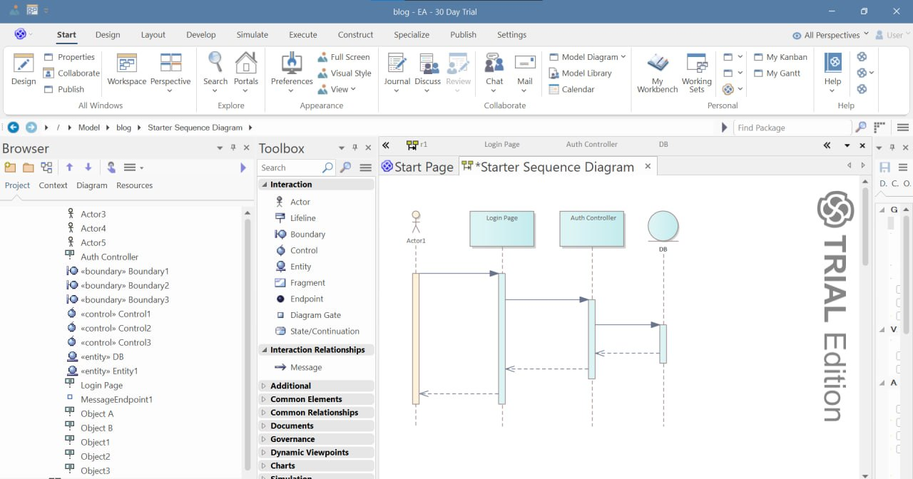

Figure 7: Sequence diagram of user authentication

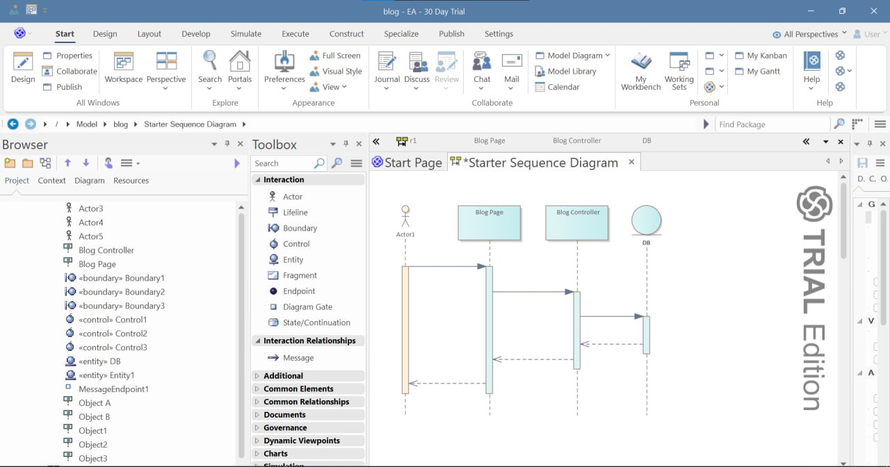

Figure 8: Sequence diagram of post creation

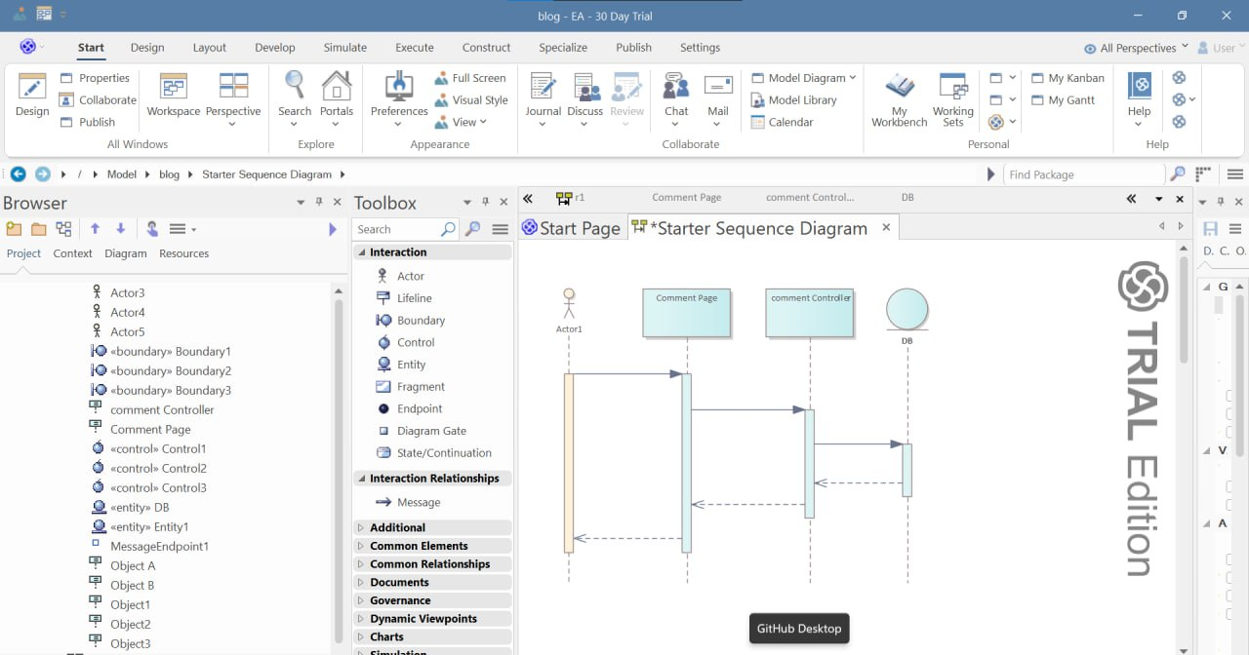

Figure 9: Sequence diagram of comment management

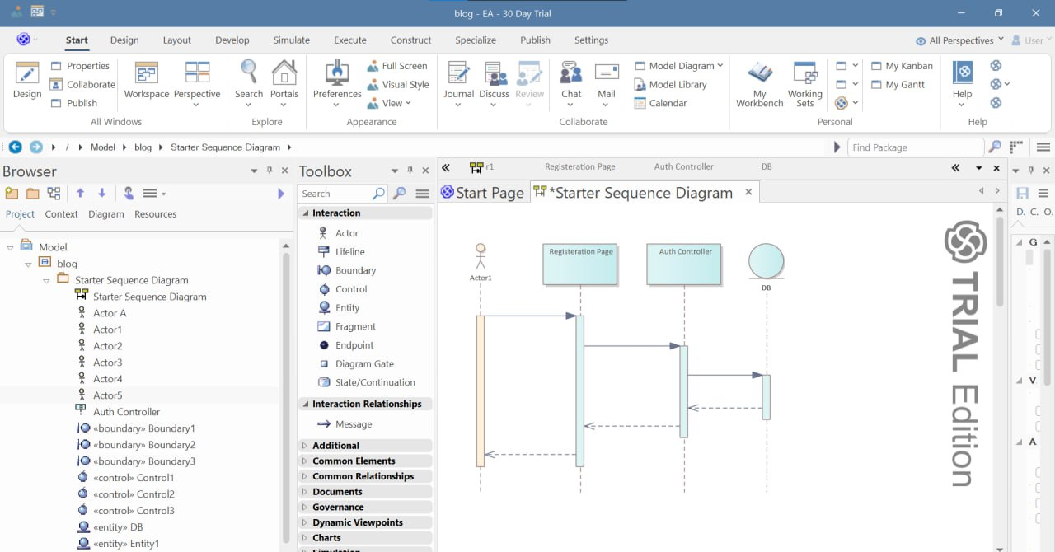

Figure 10: Sequence diagram of registration

3.4 Activity Diagrams

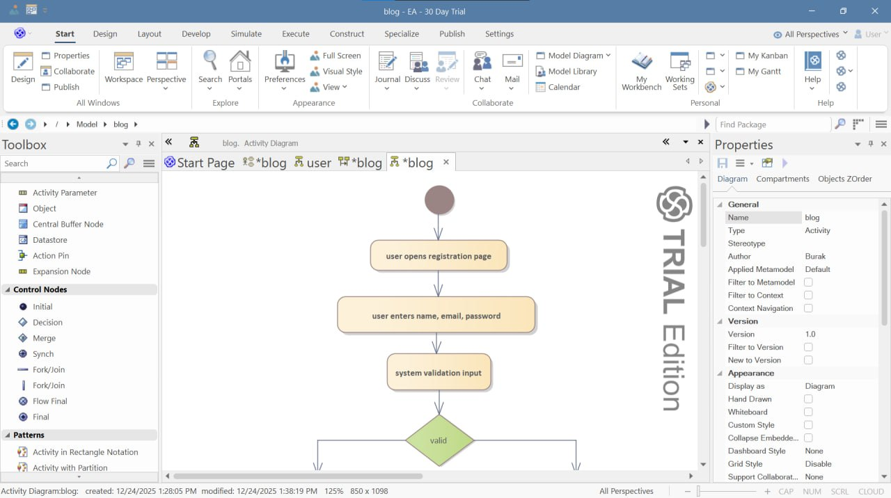

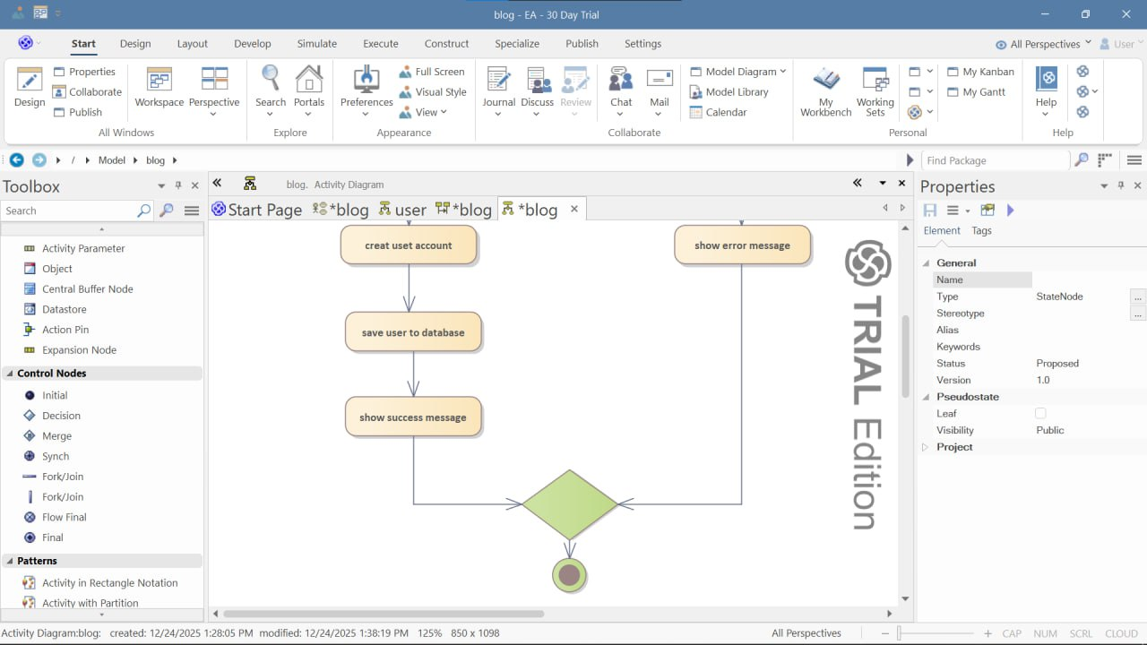

Figure 13: Activity diagram of user registration

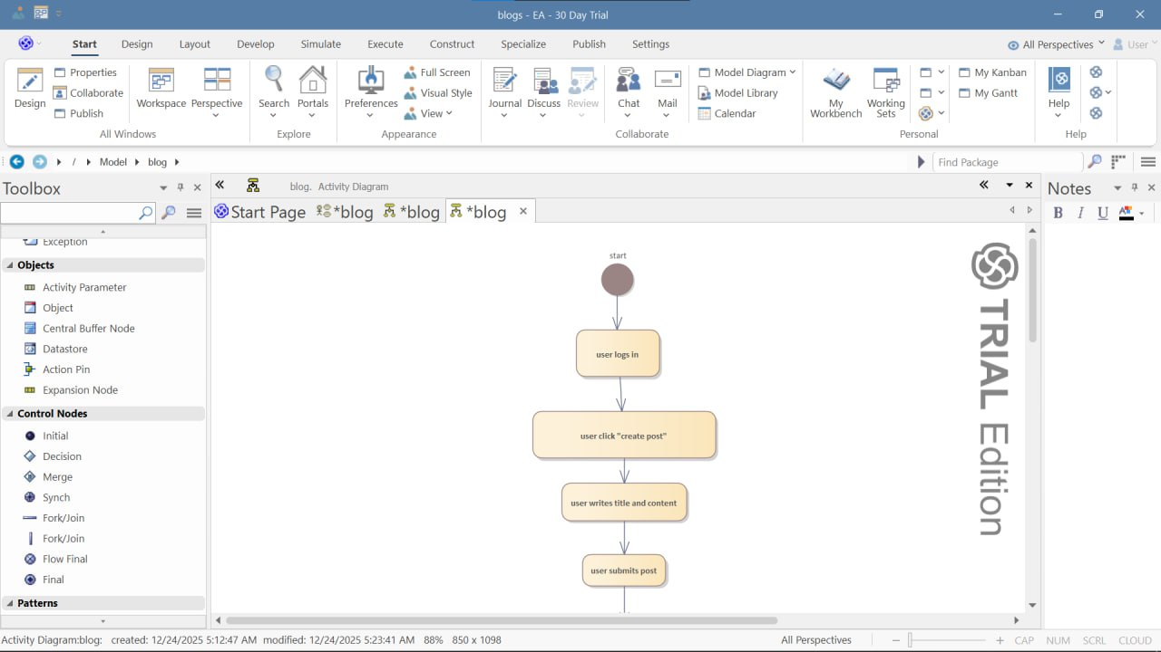

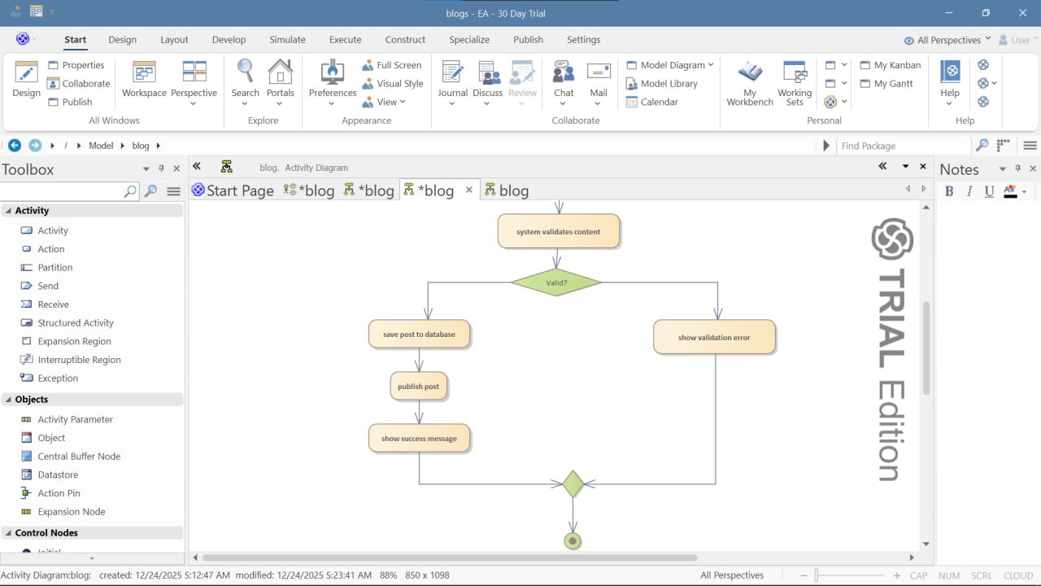

Figure 13: Activity diagram of user login

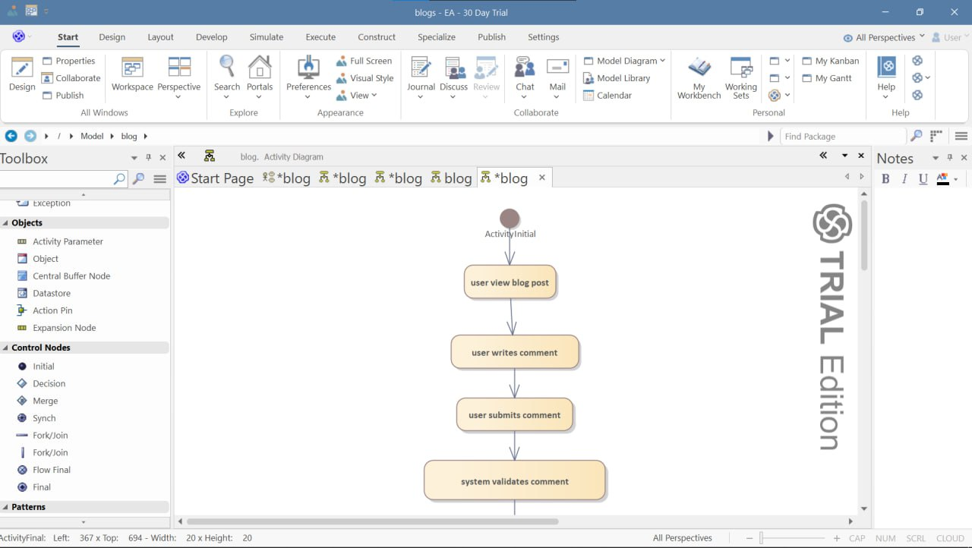

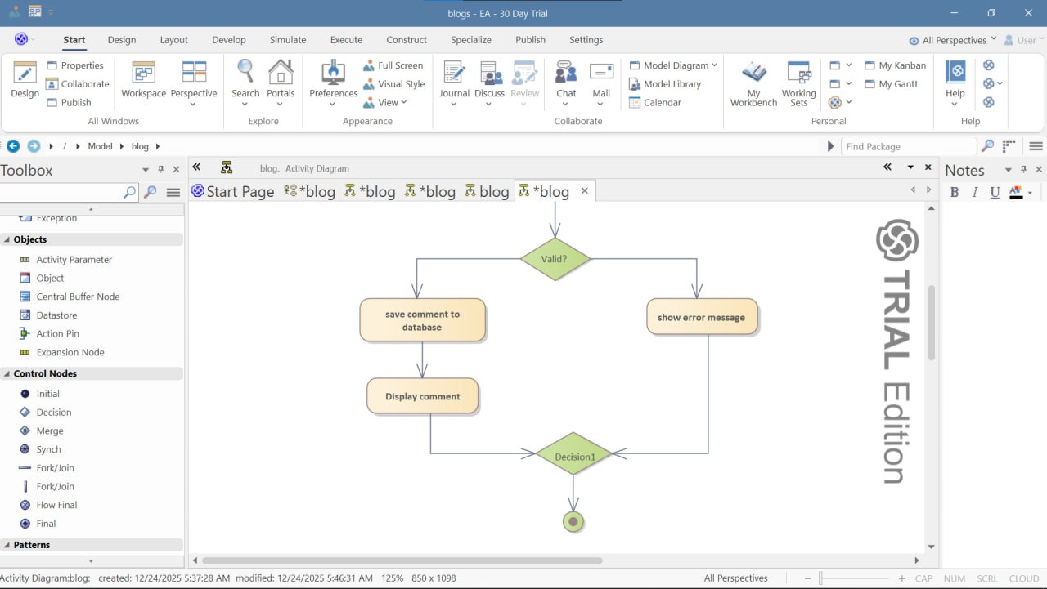

Figure 14: Activity diagram of post creation





Figure 15: Activity diagram of comment management

**CHAPTER FOUR**

**System Design**

**4.1 Overview**

The design of the proposed Blog Platform Frontend was carried out to provide a comprehensive integrated solution for managing all user interactions with the blogging platform, from user authentication to content creation, social engagement, personalized feeds, and notification management. The system is designed to be user-friendly, efficient, and scalable to meet the needs of a growing platform.

Conceptual level design: The Blog Platform Frontend design include the following components:

User Authentication Module

Post Management Module

Comment System Module

Clap System Module

Bookmark Management Module

Follow System Module

Notification System Module

Topic Management Module

User Profile Module

Search Module

Feed Module

Communication and Description of the Design: The user authentication module will be responsible for managing all user authentication and authorization, including login, registration, session management, and access control.

The post management module will assist with content creation, editing, publishing, and management, including rich text editing, media handling, and draft management.

The comment system module will handle user discussions, including comment creation, replies, threading, and moderation.

The clap system module will manage user appreciation system, including clap counting, user clap tracking, and engagement metrics.

The bookmark management module will help users save and organize content for later reading, including bookmark storage, organization, and reading progress tracking.

The follow system module will support social connections, including user-to-user follows, topic follows, and personalized feed generation.

The notification system module will handle real-time user notifications for various interactions and system events.

The topic management module will categorize and organize content for discovery and filtering.

The user profile module will manage user information, statistics, and customization options.

The search module will provide content discovery through search functionality.

The feed module will generate personalized content feeds based on user preferences and follows.

Each of these modules will be communicative between each other via a central state management system, and will have different levels of authorization and access depending on the user's authentication status. The Blog Platform Frontend system will be designed to handle high volumes of user interactions effectively and efficiently, scalable as needed to cope with platform growth.

4.1.1 Design considerations and Purposes

The design considerations and purposes of proposed blog platform frontend are as follows:

Usability: The system is user-friendly and easy to navigate, with a clear and intuitive user interface following modern design patterns.

Scalability: The system is designed to be scalable and able to handle large amounts of user interactions and high traffic loads.

Security: Robust measures should be put in place to ensure the security of user data, to protect against unauthorized access and to ensure compliance with data protection regulations.

Reliability: The system is designed to be reliable, with thorough testing and quality assurance processes to ensure the system is free from errors that could undermine the quality of user experience and compromise the integrity of the system.

User-friendly interface: The system are designed with an intuitive and easy-to-use interface that allows users to quickly and efficiently access the information they need.

Compatibility: The system are compatible with different devices, operating systems, and web browsers to ensure that users can access it from any location and device.

Performance:

The system are designed to ensuring that it can handle increasing volumes of data and users as the platform grows.

The system are designed with efficient data structures and algorithms, to minimize processing time and ensure fast response times.

The system are designed with careful consideration of the hardware and network infrastructure, to ensure that it can perform optimally given the available resources.

The system are designed with careful consideration of user experience, ensuring that it is intuitive and easy to use.

Dependability:

The system are designed with a robust and fault-tolerant architecture, ensuring that it can continue to function even in the event of browser or network failures.

The system are designed with comprehensive testing and quality assurance processes, to minimize the likelihood of bugs or defects in the software and designed with strong security features, to protect sensitive user data from unauthorized access or manipulation.

The system also designed with clear error handling and recovery mechanisms, to minimize the impact of any errors or failures that do occur.

Maintenance:

In terms of maintenance, the proposed Blog Platform Frontend is a complex system and requires regular maintenance to ensure it functions efficiently. This includes regular updates, dependency management, and system monitoring to identify and fix any issues before they become major problems.

Effective maintenance is critical to ensure the longevity and performance of the Blog Platform Frontend, and reduce long-term maintenance costs. Therefore maintenance considerations followed during the design phase of the system.

4.1.2 Design goals

The design goal of proposed blog platform frontend is to provide efficient and effective content creation and consumption experiences to users. The system is designed to manage all the areas of user interaction with features that aim to reduce friction, improve user engagement, and enhance the productivity of content creators.

Some of the specific design goals of the frontend include:

Streamlined workflow: The system are designed to streamline the workflow for content creators and readers, reducing the time and effort required to create, discover, and interact with content.

Cost savings: The system is designed to reduce development and maintenance costs, with features that enable efficient resource utilization and code reuse.

Improved user engagement: The system improve the quality of engagement provided to users, with features that facilitate better communication between users and content creators, and ensure a personalized user experience.

Data security and privacy: The system designed with security and privacy in mind, with features that ensure user data is secure and confidential at all times.

Accessibility: The system is designed to be accessible to users of all abilities, with a user-friendly interface and intuitive navigation following accessibility standards.

4.1.3 Design guidance and Issues

Design Guide for Blog Platform Frontend:

Understand the requirements: The first step in designing a blog platform frontend is to understand the requirements. Talk to the users and stakeholders and understand their needs and workflows.

Identify the key modules: Based on the requirements, identify the key modules of the system such as user authentication, post management, comment system, clap system, and notification system.

Develop a component model: Create a component model that represents the relationships between different UI components in the system. This will help to design the component hierarchy and state management.

Choose the technology stack: Choose the appropriate technology stack based on the requirements of the system. Consider factors such as scalability, security, and ease of use.

Design the user interface: Design a user interface that is easy to use and intuitive. Use appropriate colors, fonts, and icons to make it visually appealing following modern design systems.

Implement the system: Implement the system using a modular component-based approach. Test each module thoroughly before integrating it with the rest of the system.

Document the system: Provide comprehensive documentation for developers and users. Create user manuals and conduct training sessions to ensure they are comfortable with the system.

4.2 Proposed system architecture

The proposed system architecture of Blog Platform Frontend system typically consists of several layers, include:

Presentation layer: This layer consists of the user interface of the system, which includes React components, pages, forms, and interactive elements that users interact with to perform different functions. Users can access the system through a web browser.

Application Layer: This layer is responsible for the business logic of the system. It includes various services and hooks such as authentication service, post service, comment service, and notification service. Each service has its own set of rules and workflows that govern the operations of the platform.

State Management Layer: This layer includes the state management system that manages all the application state. The state management layer is responsible for managing state integrity, predictability, and accessibility.

API Integration Layer: This layer is responsible for communicating with backend APIs. It includes various API clients, request/response interceptors, and data transformation logic. The API layer helps abstract backend communication and handle errors consistently.

Routing Layer: This layer manages navigation and URL routing within the single-page application. It includes route definitions, navigation guards, and history management.

Security Layer: This layer is responsible for ensuring the security and privacy of sensitive data. It includes various security measures such as JWT token management, request authentication, and data encryption. The security layer helps prevent unauthorized access to user information and protects the platform from security breaches.

Infrastructure Layer: This layer includes the build tools, development tools, and deployment infrastructure required to develop and run the Blog Platform Frontend. It includes bundlers, transpilers, testing frameworks, and other components that are necessary for the system to function.

In general the overall architecture of proposed Blog Platform Frontend is simulated below.

Figure 19: System architecture of proposed Blog Platform

[Browser] → [React Application] → [Component Layer] → [Service Layer] → [State Management] → [API Layer] → [Backend Server]

4.2.1 System process

The process of system design for a proposed blog platform frontend includes a series of activities that help to transform the requirement specifications into an implementation. These activities include:

Gathering and analyzing the functional and non-functional requirements of the blog platform frontend. This includes identifying the system's stakeholders, their needs, and the user journeys that the system will support.

Creating a system design that meets the identified requirements. This includes specifying the system's architecture, defining the system's components, and designing the user interfaces, state management, and communication mechanisms.

Documenting the system design. This include creating specifications, design documents, component libraries, and other artifacts that describe the system's design in detail.

Reviewing and validating the system design. This involves checking the design against the requirements to ensure that it meets the stakeholders' needs and is feasible to implement.

Implementing the system design. This involves programming the system components, setting up the development environment, and integrating the system components together.

Testing the system implementation. This involves verifying that the system works as expected, meets the requirements, and is reliable, performant, and maintainable.

Deploying the system. This involves building and releasing the system to its users and ensuring that it is supported and maintained over time.

4.2.2 Subsystem decomposition

The sub-system decomposition process of the proposed Blog Platform Frontend involve identifying the major subsystems of the system. From there, each subsystem would be further broken down into smaller modules and components until the system's overall functionality is achieved. Here is the overall sub-system decomposition of proposed Blog Platform Frontend.

Figure 20: System decomposition of proposed Blog Platform

Core System:

Authentication Subsystem

User Management Subsystem

Content Subsystem

Content System:

Post Management Module

Comment System Module

Clap System Module

Social System:

Follow System Module

Bookmark Module

Notification Module

Discovery System:

Search Module

Feed Module

Topic Module

Support System:

UI Component Library

State Management

API Integration

Routing System

4.2.3 Hardware/Software mapping

Hardware components:

User devices (computers, smartphones, tablets)

Development machines

Testing devices

Network infrastructure

Software components:

Operating systems (Windows, macOS, Linux, iOS, Android)

Web browsers (Chrome, Firefox, Safari, Edge)

Development environment (Node.js, npm/yarn, Git)

Frameworks and libraries (React, Redux, React Router)

Build tools (Vite, Webpack, Babel)

Testing tools (Jest, React Testing Library, Cypress)

4.2.4 Persistent data management

In proposed Blog Platform Frontend, persistent data include user preferences, local drafts, cached content, and offline data.

To ensure the persistence of this data, we make the frontend to have robust mechanisms for persistent data storage, retrieval, and synchronization. This typically involves using browser storage APIs (localStorage, sessionStorage, IndexedDB) that support data persistence across sessions.

The storage system has sufficient capacity and performance to handle the user data generated by the Blog Platform Frontend. Data in the frontend is typically stored in structured formats, such as JSON that can be efficiently retrieved and updated.

Moreover, the proposed Blog Platform Frontend have appropriate security measures in place to protect the persistent data from unauthorized access, modification, and deletion. Include encryption, secure storage practices, and data validation.

4.3 Design Control

Configuration control system: A good configuration control system can be in placed to ensure that changes to the design, code, or other elements of the project are properly tracked and documented using version control (Git).

Design inputs verification: To ensure that the design meets the specifications and requirements, design inputs is verified as being adequate. This verification process is properly documented to ensure traceability and accountability through design reviews and user testing.

Design verification: The design output is verified to ensure that it meets the required quality standards, and performs as expected through prototyping and usability testing.

Design output quality: The design output, including the UI components and user flows, has required quality, and rigorous testing is carried out to ensure that it meets the required standards and is free of usability issues.

Control of design changes: Controls is putted in place to manage and control changes to the design, code, or other elements of the project. Include a robust change management process, version control for code, and formal review processes for proposed changes through pull requests and code reviews.

4.4 Low-level design model

4.4.1 State chart diagram  
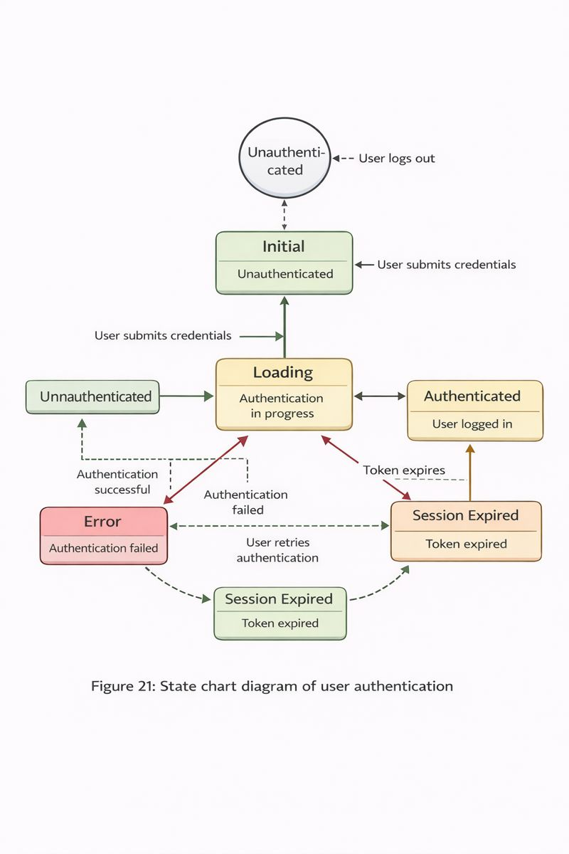

States:

Initial: Unauthenticated

Loading: Authentication in progress

Authenticated: User logged in

Error: Authentication failed

Session Expired: Token expired

Transitions:

Unauthenticated → Loading: User submits credentials

Loading → Authenticated: Authentication successful

Loading → Error: Authentication failed

Authenticated → Session Expired: Token expires

Session Expired → Loading: User re-authenticates

Error → Loading: User retries authentication

Any state → Unauthenticated: User logs out

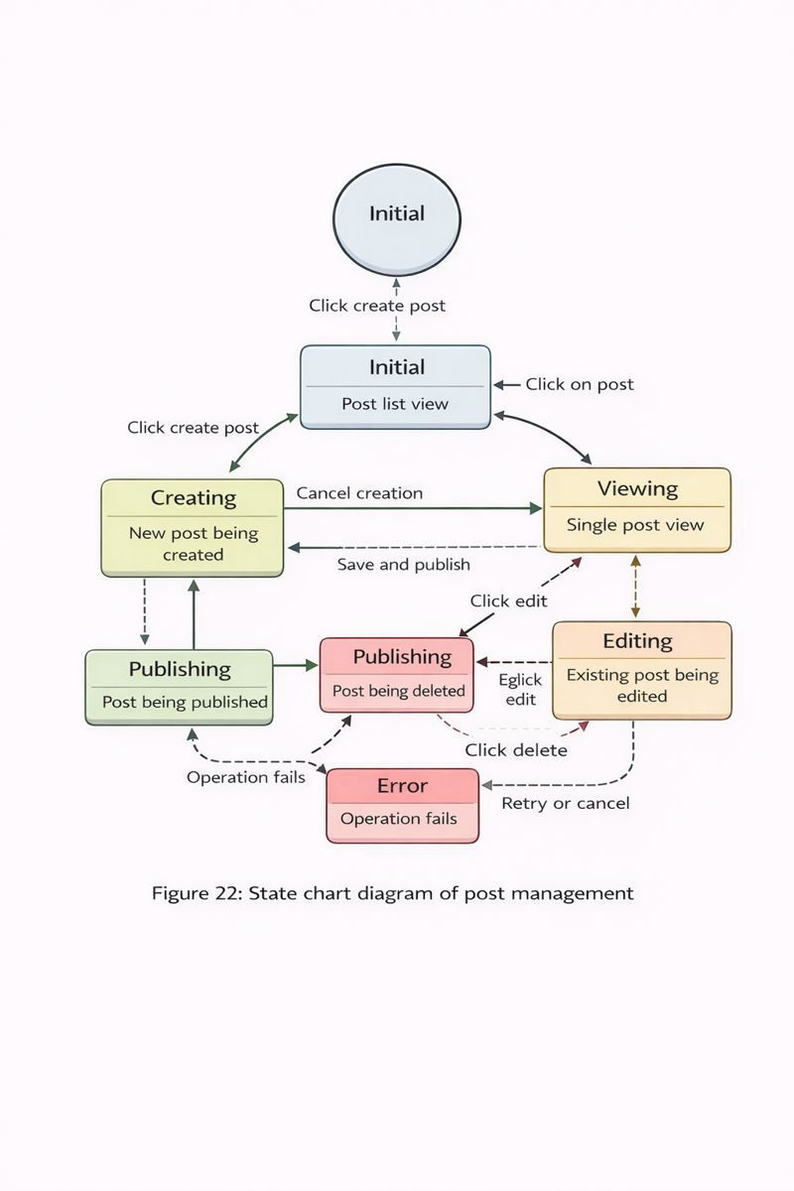

States:

Initial: Post list view

Creating: New post being created

Editing: Existing post being edited

Viewing: Single post view

Publishing: Post being published

Deleting: Post being deleted

Error: Operation failed

Transitions:

Initial → Creating: Click create post

Initial → Viewing: Click on post

Creating → Initial: Cancel creation

Creating → Publishing: Save and publish

Viewing → Editing: Click edit

Editing → Viewing: Save edits

Editing → Deleting: Click delete

Any operation → Error: Operation fails

Error → Previous state: Retry or cancel

4.4.2 Component diagram

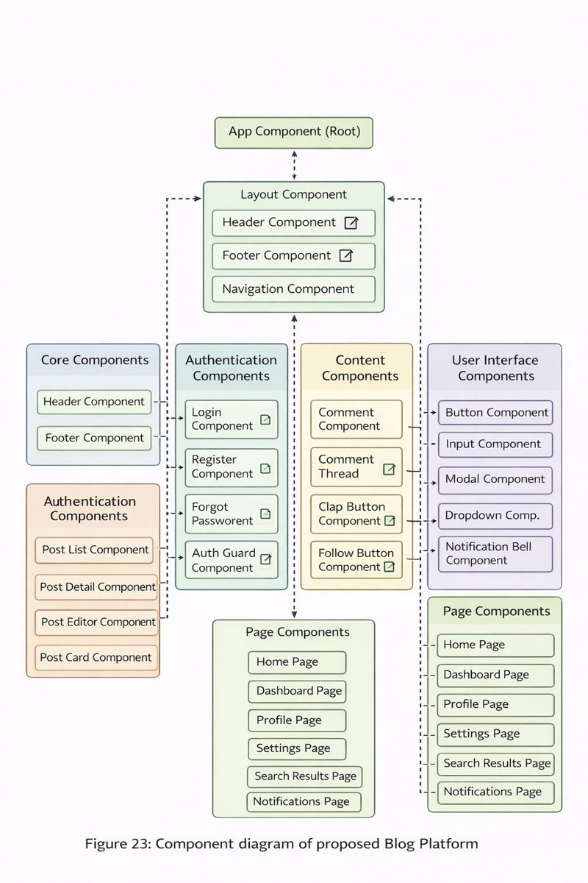

Core Components:

App Component (Root)

Layout Component

Header Component

Footer Component

Navigation Component

Authentication Components:

Login Component

Register Component

Forgot Password Component

Auth Guard Component

Content Components:

Post List Component

Post Detail Component

Post Editor Component

Post Card Component

Social Components:

Comment Component

Comment Thread Component

Clap Button Component

Follow Button Component

Bookmark Button Component

User Interface Components:

Button Component

Input Component

Modal Component

Dropdown Component

Notification Bell Component

Search Bar Component

Page Components:

Home Page

Dashboard Page

Profile Page

Settings Page

Search Results Page

Notifications Page

4.4.3 Deployment diagram

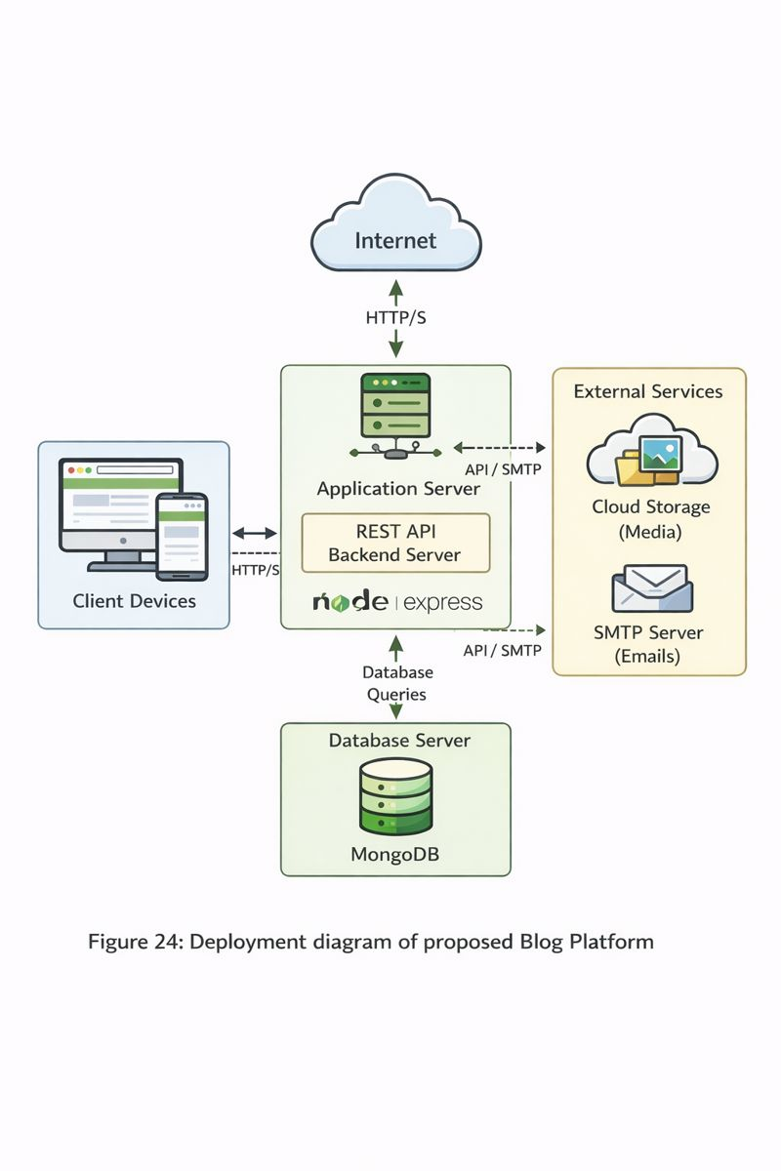

Client Side:

Web Browser (User Device)

React Application Bundle

Static Assets (CSS, Images, Fonts)

Browser Storage (localStorage, sessionStorage)

Server Side:

Web Server (Hosting)

Static File Server

CDN for assets

Backend API Server (External)

Authentication Endpoints

Content Endpoints

Notification Endpoints

Development Environment:

Development Server

Build Tools

Testing Environment

Version Control System

External Services:

Analytics Service

Error Tracking Service

Performance Monitoring

Third-party APIs

4.5 Database Design

Figure 25: Component structure of proposed Blog Platform

Component Hierarchy:

text

App

├── Layout

│ ├── Header

│ │ ├── Navigation

│ │ ├── SearchBar

│ │ └── UserMenu

│ └── MainContent

├── Routes

│ ├── HomePage

│ │ └── Feed

│ ├── PostPage

│ │ ├── PostDetail

│ │ └── CommentSection

│ ├── ProfilePage

│ │ ├── UserInfo

│ │ └── UserPosts

│ └── SettingsPage

└── Common

├── Modals

├── Notifications

└── Loaders

State Management Structure:

text

Redux Store

├── Auth Slice

│ ├── user

│ ├── token

│ └── status

├── Posts Slice

│ ├── posts

│ ├── currentPost

│ └── drafts

├── Comments Slice

│ ├── comments

│ └── replies

├── UI Slice

│ ├── theme

│ ├── notifications

│ └── modals

└── User Slice

├── profile

├── bookmarks

└── follows

4.5.1 Data Dictionary

Table 25: User Component Data

|  |  |  |
| --- | --- | --- |
| Field Name | type | Description |
| id | String | Primary key |
| username | String | Unique username |
| email | String | User email |
| displayName | String | Display name |
| avatar | String | Profile image URL |
| bio | String | User biography |
| createdAt | Data | Account creation date |
| updateAT | Dta | Last profile update |

Field name Type Description

Table 26: Post Component Data

|  |  |  |
| --- | --- | --- |
| Field Name | type | Description |
| id | String | Primary key |
| title | String | Post title |
| content | string | Post content (HTML) |
| authorId | String | Reference to user |
| topics | Array | Associated topics |
| clapsCount | number | Total claps |
| commentsCount | number | Total comments |
| status | string | draft/published/deleted |
| createdat | date | Creation timestamp |
| publish | date | Publication timestamp |

Table 27: Comment Component Data

|  |  |  |
| --- | --- | --- |
| Field Name | type | Description |
| id | String | Primary key |
| content | String | Comment text |
| authorId | String | Reference to user |
| topicid | String | Reference to post |
| post ID | String | Parent comment (for replies |
| clapsCount | String | Claps on comment |
| createdAt | String | Creation timestamp |
| updateAT | String | Update timestamp |

Table 28: Topic Component Data

|  |  |  |
| --- | --- | --- |
| Field Name | type | Description |
| id | String | Primary key |
| name | String | Topic name |
| slug | String | URL-friendly name |
| description | String | Topic description |
| followersCount | String | Number of followers |
| postsCount | String | Number of posts |
| createdAt | String | Creation date |

Table 29: Notification Component Data

|  |  |  |
| --- | --- | --- |
| Field Name | type | Description |
| id | String | Primary key |
| userId | String | Recipient user ID |
| type | String | Notification type |
| message | String | Additional data |
| data | object | Read status |
| read | Boolean | Creation timestamp |
| createdAt | Date | Creation date |

Table 30: Bookmark Component Data

|  |  |  |
| --- | --- | --- |
| Field Name | Type | Description |
| id | String | Primary Key |
| useIid | String | User who bookmarked |
| postid | String | Bookmarked post |
| notes | String | User notes |
| createdAt | String | Bookmark date |
| LastViews | String | Last view date |

4.6 Boundary condition and Access control

The proposed system have clear boundary conditions that define its scope and the types of users who are authorized to access different features. These boundary conditions can be defined based on the platform's specific needs and user roles. For example, the system have a boundary condition that only allows authenticated users to create content or interact socially.

The proposed Blog Platform Frontend exhibit the following quality attributes of a system under construction:

The system is designed in a way that allows modifications to be made easily without causing extensive changes to the overall system. This is important since a platform's requirements can change over time, and the system adapt to these changes through component composition and prop drilling patterns.

The system allow for components to be easily swapped out or replaced with other compatible components through consistent interfaces and props contracts.

The system is designed in a way that allows components to be easily reused in other parts of the system or in other projects through a well-designed component library.

The system is designed in a way that allows for new features and functionality to be added easily in the future. The platform's requirements may change over time, and the system is able to accommodate these changes without extensive modifications through modular architecture.

The proposed system is designed in a way that allows for easy maintenance and upkeep through clear code organization, documentation, and testing strategies.

4.6.1 Access controlling

Access control mechanisms is already implemented in proposed system to limit access to features based on user authentication and authorization. It includes:

User authentication: Only authenticated users can access certain features. Users need to enter valid credentials to log in to the system and receive a JWT token for subsequent requests.

Role-based access control: In proposed system we implement Role-based access control to ensure that users have access to only the features they are authorized to use. Roles can be assigned based on the user's status (guest, user, moderator, admin). Each role have a set of permissions that define the actions that the user can perform.

Component guards: Certain React components can be guarded to only render for authorized users. For example, the PostEditor component only renders for authenticated users, while the CommentForm component might have additional restrictions.

Route protection: Certain routes can be protected to prevent unauthorized access. For example, the /dashboard route might require authentication, while the /settings route might require additional permissions.

Feature flags: Access to certain features can be controlled through feature flags that can be toggled based on user roles, subscription tiers, or A/B testing groups.

4.7 Conclusion and Recommendation

4.7.1 Conclusions

A Blog Platform Frontend is a software solution that streamlines and enhances the user experience of content creation, discovery, and social interaction in a blogging platform. The implementation of proposed blog platform frontend helps to improve the efficiency and effectiveness of the platform operations, thereby enhancing the quality of user engagement and increasing the value of the platform.

With the modern design and implementation of the blog platform frontend, there are several benefits that can be realized. Firstly, the system can help to reduce user friction and ensure that all the necessary features are accessible and intuitive. This can help to prevent user abandonment and improve user retention.

Secondly, the system can help to streamline the content creation process and the tracking of user engagement. This can help to improve the overall efficiency of the platform, reduce barriers to content creation, and improve the quality of community interactions.

Thirdly, the system can help to improve communication between different user groups within the platform and between the platform and external stakeholders such as social media. This can help to reduce isolation, improve collaboration, and ensure that all stakeholders are engaged in the community building process.

Overall, the implementation of proposed blog platform frontend can have a significant impact on the quality of experience provided by the platform, the efficiency of its operations, and the satisfaction of both content creators and readers. By modernizing the user interface and experience, the platform can improve the accessibility, speed, and effectiveness of its operations, ultimately leading to better user outcomes and a more successful digital platform.

4.7.2 Recommendation

The system that we develop is a modern web-based Blog Platform Frontend for social blogging. While doing this system the team members has faced different challenges. But by the cooperation of all the group members the team is now able to reach to the final result. I.e. all the group members strongly fight these challenge and take the turn to the front.

The proposed Blog Platform Frontend is designed with great attention to detail, taking into account the specific needs of modern blogging platforms. User experience and engagement are top priorities at all stages of the design and implementation process. Furthermore, we recommended that adequate documentation and developer support be provided to ensure that the system can be maintained and extended effectively.

Possible Future Improvement

We recommended that the system may have better improvement in the future since the current system is being designed with extensibility in mind. It can be enhanced with more features such as real-time collaboration, advanced analytics dashboards, and AI-powered content recommendations in the future which may help the users to have more engaging experiences with lesser effort.

4.8 Reference

Dennis, A., Wixom, B. H., & Tegarden, D. (2010). System Analysis and Design with UML Version 2.0: An Object Oriented Approach (3rd ed.). Hoboken, NJ: John Wiley & Son.

React Documentation. (2023). React: A JavaScript library for building user interfaces. Retrieved from https://reactjs.org/docs

Redux Documentation. (2023). Redux: A predictable state container for JavaScript apps. Retrieved from https://redux.js.org

Fielding, R. T. (2000). Architectural Styles and the Design of Network-based Software Architectures. Doctoral dissertation, University of California, Irvine.

Gamma, E., Helm, R., Johnson, R., & Vlissides, J. (1994). Design Patterns: Elements of Reusable Object-Oriented Software. Addison-Wesley Professional.

An integrated approach to software engineering, Third edition by Pankaj Jalote

Software engineering By Ian Sommerville